**II. Synchronous Generators**

* ***Synchronous machines*** are principally used as ***alternating current (AC) generators***. They supply the electric power used by all sectors of modern societies: industrial, commercial, agricultural, and domestic.
* ***Synchronous generators*** usually operate together (or in parallel), forming a large power system supplying electrical energy to the loads or consumers.
* ***Synchronous generators*** are built in large units, their rating ranging from tens to hundreds of megawatts.
* ***Synchronous generator*** converts mechanical power to ac electric power. The source of mechanical power, ***the prime mover***, may be a diesel engine, a steam turbine, a water turbine, or any similar device.
* For high-speed machines, the prime movers are usually ***steam turbines***

employing fossil or nuclear energy resources.

* Low-speed machines are often driven by ***hydro-turbines*** that employ water power for generation.
* Smaller synchronous machines are sometimes used for private generation and as standby units, with diesel engines or gas turbines as prime movers.

### Types of Synchronous Machine

According to the ***arrangement of the field and armature windings***, synchronous machines may be classified as ***rotating-armature type*** or ***rotating-field type***.

***Rotating-Armature Type:*** The armature winding is on the rotor and the field system is on the stator.

***Rotating-Field Type:*** The armature winding is on the stator and the field system is on the rotor.

According to the shape of the field, synchronous machines may be classified as

*cylindrical-rotor* (*non-salient pole*) *machines* and *salient-pole machines*

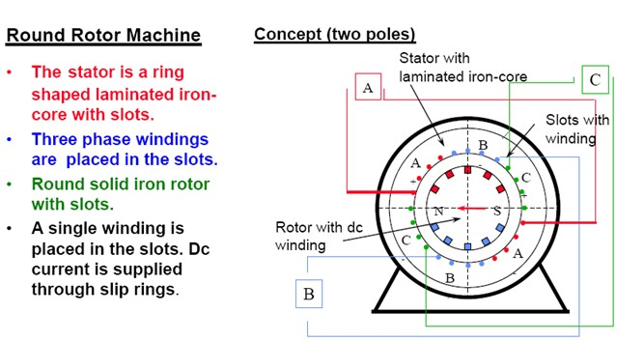

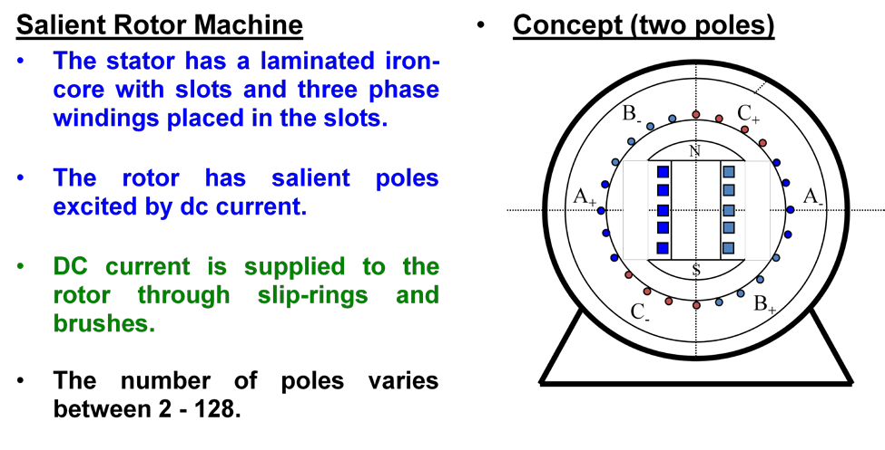

**Construction**

* The winding consists of copper bars insulated with mica and epoxy resin.
* The conductors are secured by steel wedges.
* 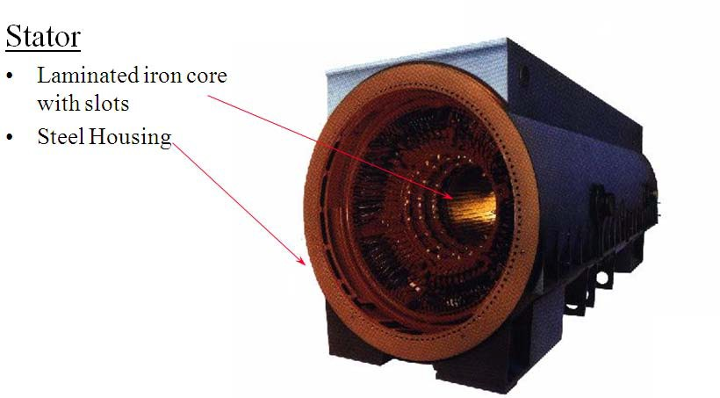The iron core is supported by a steel housing.

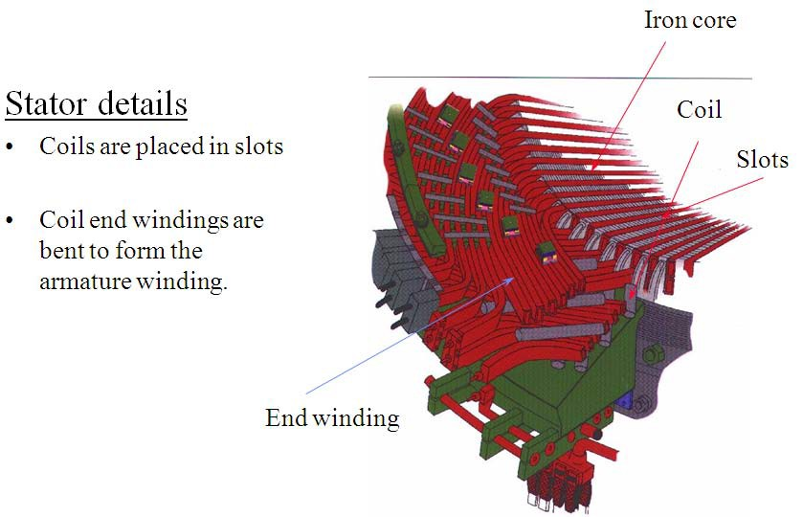

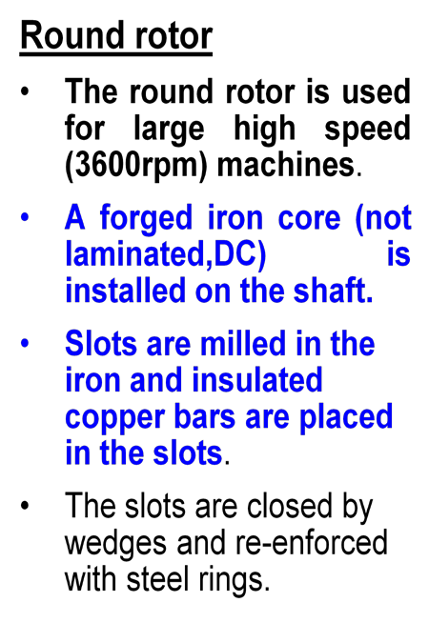 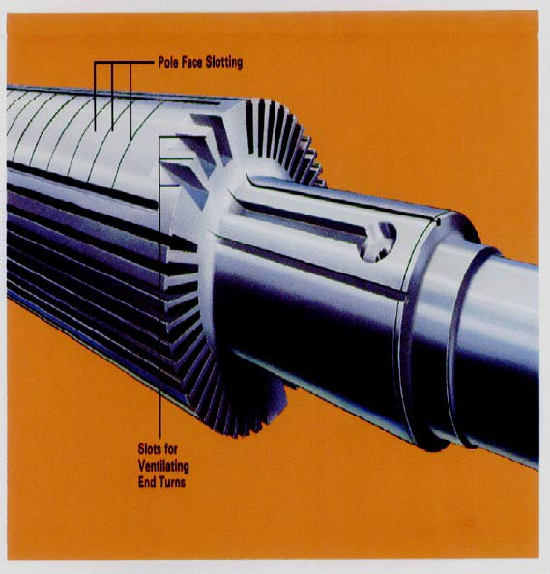

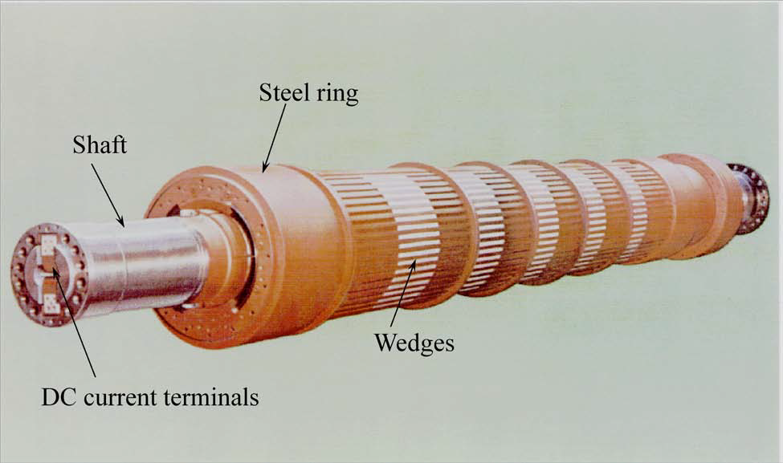**Round rotor**

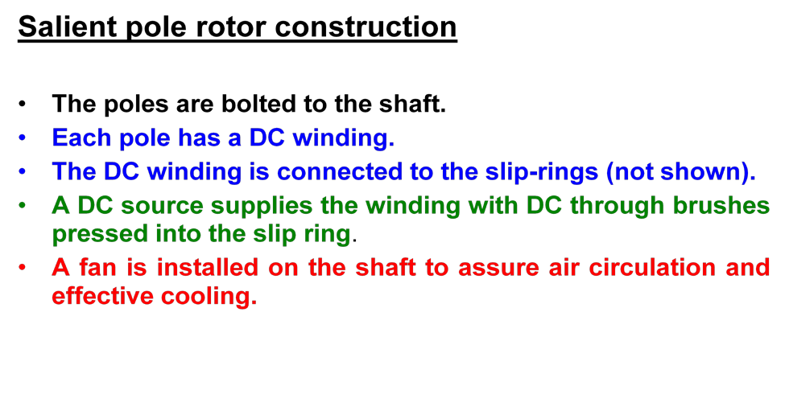

* **Low speed, large hydro-generators may have more than one hundred poles.**
* **These generators are frequently mounted vertically**

**Salient Rotor**

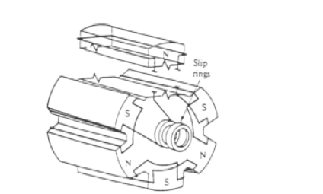

**Field Excitation and Exciters**

* + DC field excitation is an important part of the overall design of a synchronous generator
  + The field excitation must ensure not only a stable AC terminal voltage, but must also respond to sudden load changes
  + Rapid field excitation response is important

***Three methods of excitation***

1. ***slip rings*** link the rotor’s field winding to an external dc source

1. ***dc generator exciter***
   * a dc generator is built on the same shaft as the ac generator’s rotor
   * a commutator rectifies the current that is sent to the field winding
2. ***brushless exciter***
   * an ac generator with fixed field winding and a rotor with a three phase circuit
   * diode/SCR rectification supplies dc current to the field windings

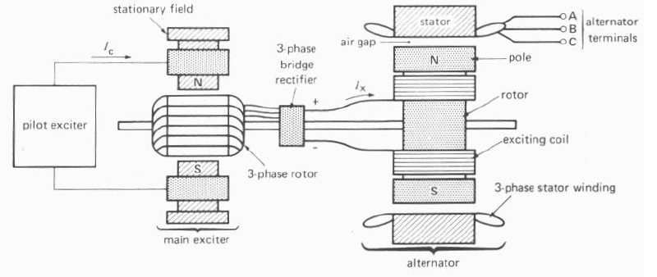

**Typical brushless exciter system**

### Ventilation or Cooling of an Alternator

* + The slow speed salient pole alternators are ventilated by the fan action of the salient poles which provide circulating air.
  + Cylindrical rotor alternators are usually long, and the problem of air flow requires very special attention.
  + The cooling medium, air or hydrogen is cooled by passing over pipes through which cooling water is circulated and ventilation of the alternator.
  + Hydrogen is normally used as cooling medium in all the turbine-driven alternators because hydrogen provides better cooling than air and increases the efficiency and decreases the windage losses.
  + Liquid cooling is used for the stators of cylindrical rotor generators.

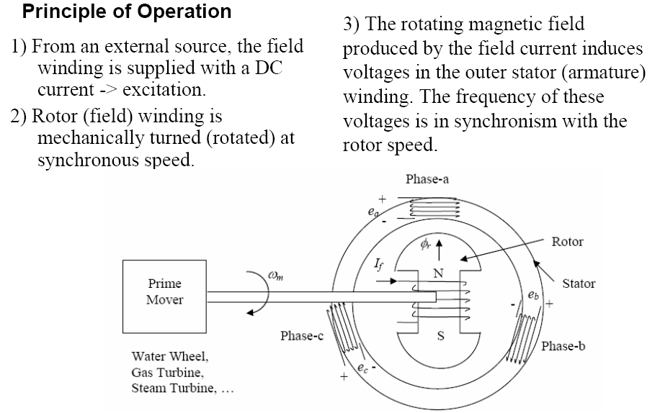

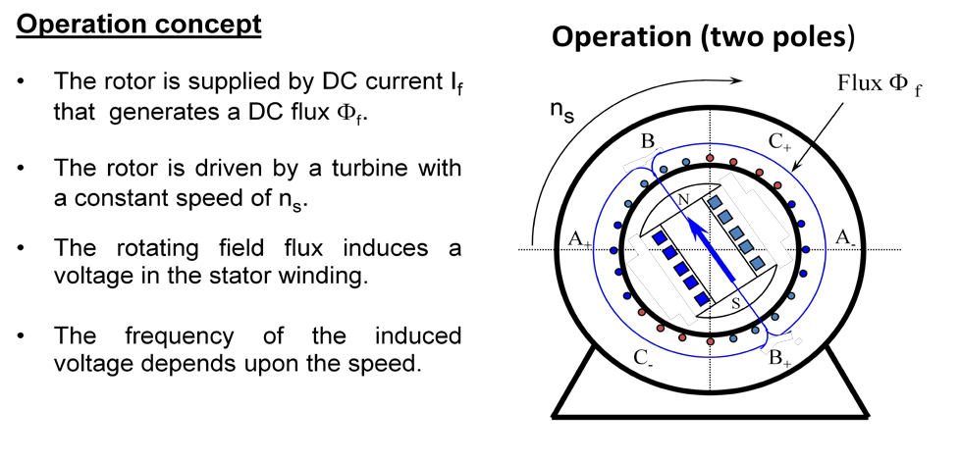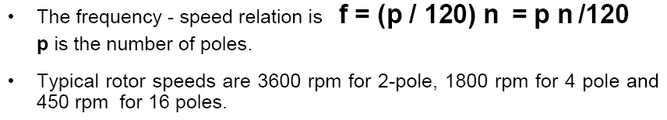

###### The rms. value of the induced voltages are:

*Ean*

 *Erms e*

*i O* deg

*Ebn*

 *Erms e*

*i*120deg

*Ecn*

 *Erms e*

*i* 240deg

###### where:

*Erms* 

*kw  Na*  *f*

 4.44 *f*

*Na*  *f kw*

###### kw = 0.85-0.95 is the winding factor.

2

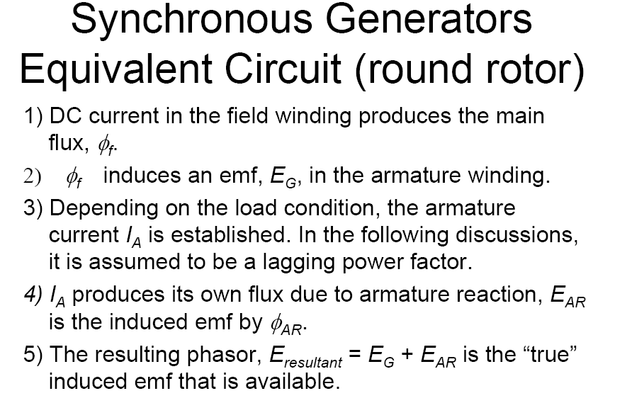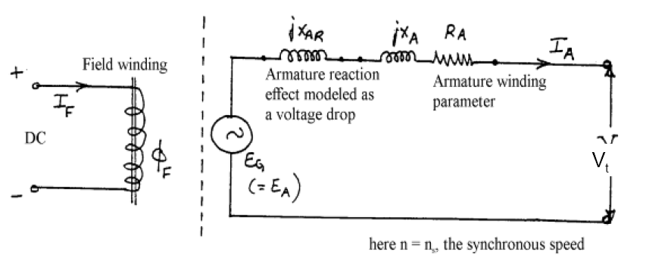

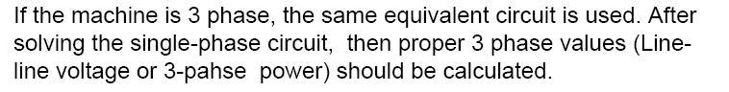

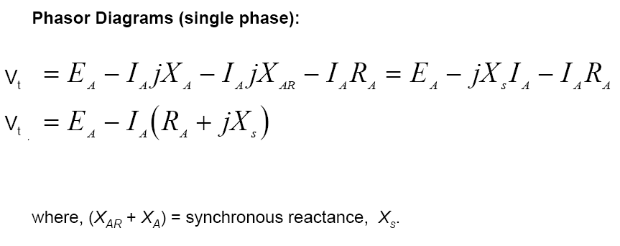

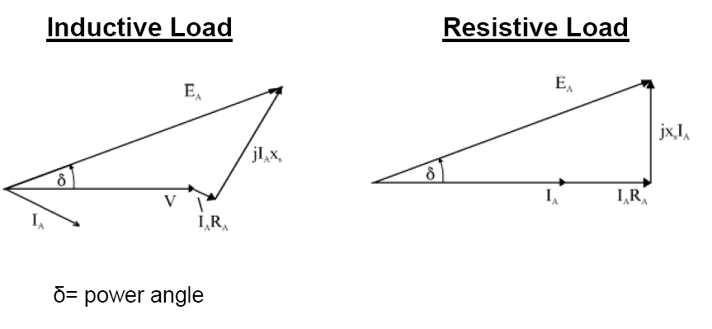

Φ

**H.W**

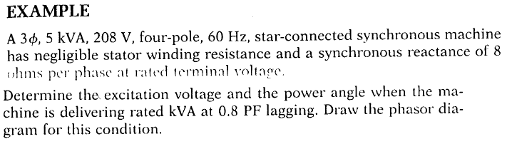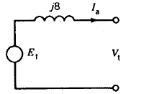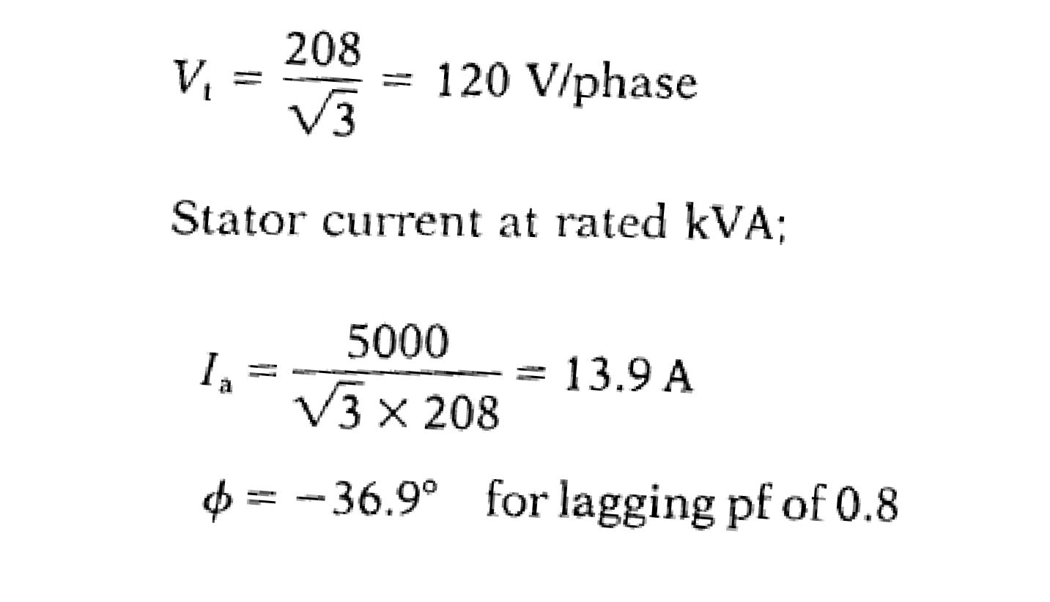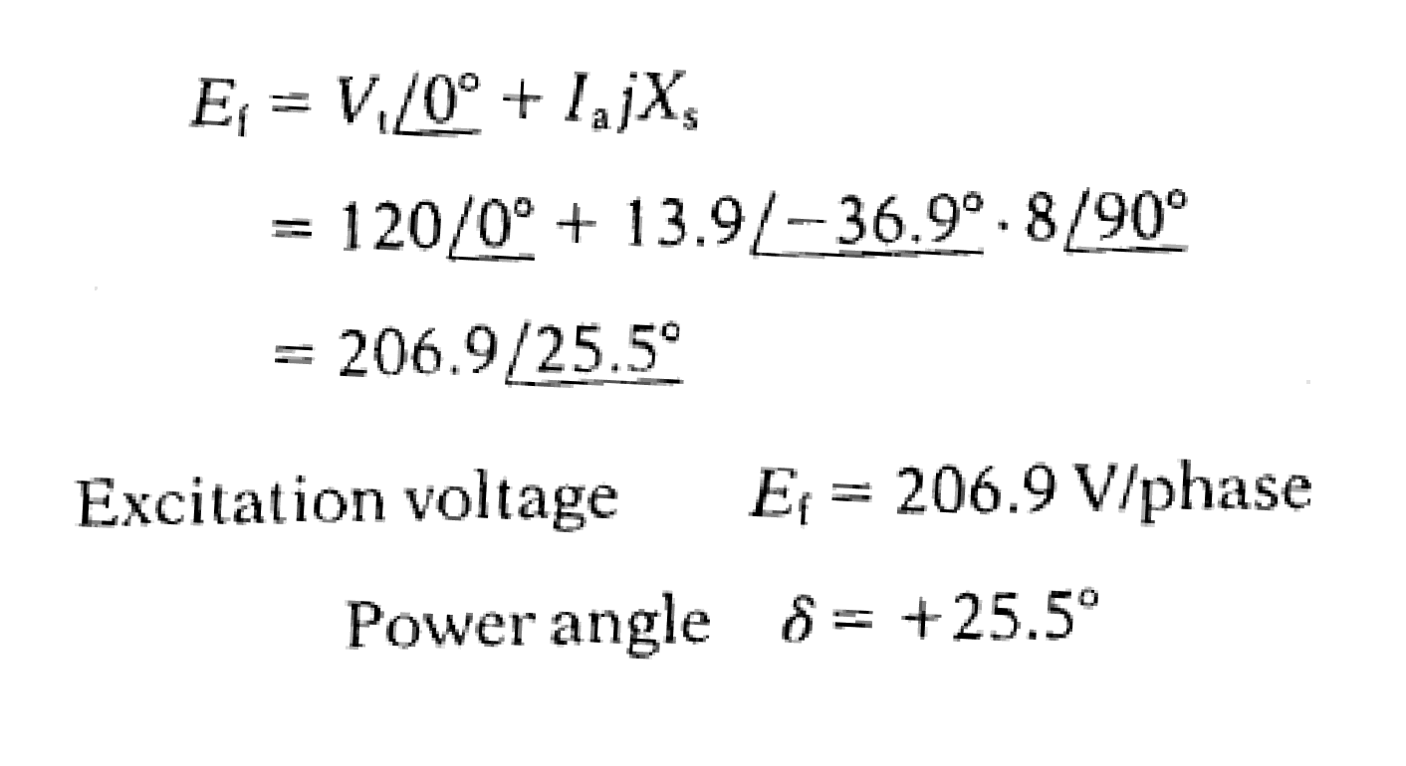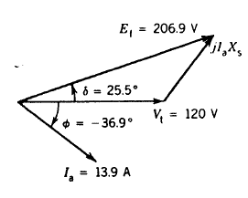

A four pole, three-phase synchronous generator is rated 250 MVA, its terminal voltage is 24 kV, the synchronous reactance is: 125%.

* Calculate the synchronous reactance in ohm.
* Calculate the rated current and the line to ground terminal voltage.
* Draw the equivalent circuit.
* Calculate the induced voltage, Ef , at rated load and pf = 0.8 lag.

###### (Ans: Xsyn=2.88Ω, Ig=6.01∟-36.87oKA, Egn=27.93∟29.74KV)

**Armature Reaction in Synchronous Machines**

*Armature reaction* refers to

* the influence on the magnetic field in the air gap when the phase windings a, b, and c on the stator are connected across a load.
* The flux produced by the armature winding reacts with the flux set up by the poles on the rotor, causing the total flux to change.
* 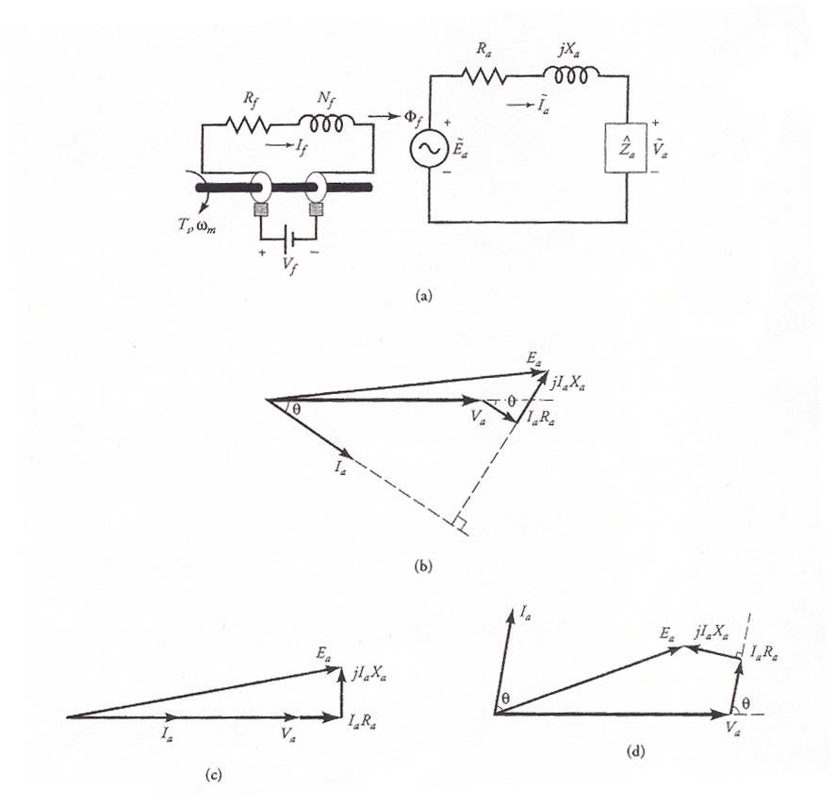*The generator delivers a load at a unity power factor.*

**Figure.1 *(a)* The per-phase equivalent circuit of a synchronous generator without armature reaction while depicting the revolving field produced by the rotor. The phasor diagrams for a *(b)* lagging pf, *(c)* unity pf, and *(d)* leading pf.**

* 1. If *p* is the flux per pole in the generator under no load, then the generated voltage *Ea* must lag *p* by 90o, as shown in Figure 2.
  2. Since the power factor is unity, the phase current ~

*Ia*

terminal phase voltage ~ .

*Va*

is in phase with the

* 1. As the phase current ~

*Ia*

passes through the armature winding, its

magnetomotive force (mmf) produces a flux *ar*

## ~

which is in phase with

*Ia* . The effective flux *e* per pole in the generator is the algebraic sum of

the two fluxes; that is, *e* = *p* + *ar*, as shown in the figure.

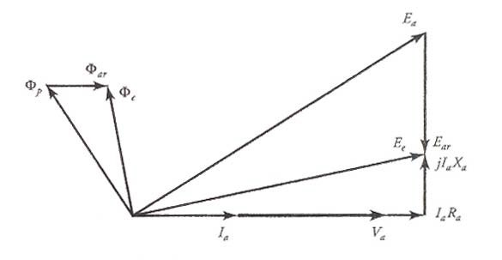

**Figure 2: Phasor diagram depicting the effect of armature reaction when the power factor is unity.**

* 1. The flux *ar*, in turn, induces an emf

~

*Ear* in the armature winding.

~

*Ear* is

called the **armature reaction** emf. The armature reaction emf ~

*Ear*

the flux *ar* by 90o. Hence the effective generated voltage per-phase

lags

## ~

*E*

is the algebraic sum of the no-load voltage ~

*Ea*

*Ee*

*e*

and the armature reaction

## ~

emf

*Ear*

. That is, ~

~

 *Ea*

~

* *Ear*

.

An equivalent circuit showing the

armature reaction emf is given in Figure 3.

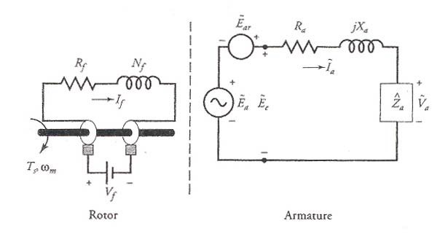

**Figure 3: A per-phase equivalent circuit showing the induced emf in the armature winding due to the armature reaction.**

* 1. The per-phase terminal voltage ~

*Va*

is obtained by subtracting the voltage drops

##### ~ ~ ~

*Ia Ra* and *j Ia Xa*

from

*Ee* . In other words,

##### ~  ~

 ~ ( *R*

* *j X* )

*Ee Va*

*Ia a a*

From the phasor diagram, it should be obvious that the armature reaction has reduced the effective flux per pole when the power factor of the load is unity.

Also, the terminal voltage is smaller than the generated voltage.

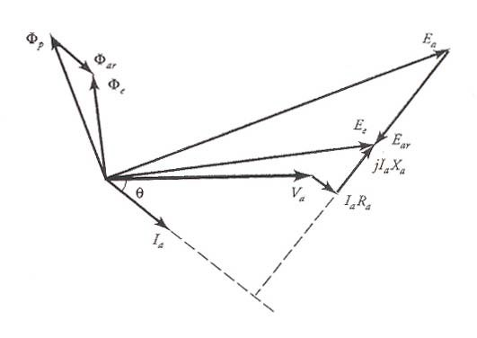

**Figure 4: The phasor diagram showing the effect of armature reaction when the power factor is lagging.**

By following the above sequence of events, we can obtain the phasor diagrams for the lagging (Figure 4) and the leading (Figure 5) power factors. From these figures it is evident that the resultant flux is (smaller/larger) with armature reaction for the

(lagging/leading) power factor than without it. In addition, the terminal voltage ~

*Va*

is (higher/lower) than the generated voltage ~

*Ea*

when the power factor is (leading/

lagging). Since the flux per pole *p* is different for each of the three load

conditions, the field current *If*

must be

adjusted each time the load is changed.

##### ~

~ o

Since the armature reaction emf express it as

*Ear*

lags the current

*Ia* by 90 , we can also

## ~ ~

*Ear*   *j Ia Xm*

where *Xm*, a constant of proportionality, is known as the **magnetization reactance**.

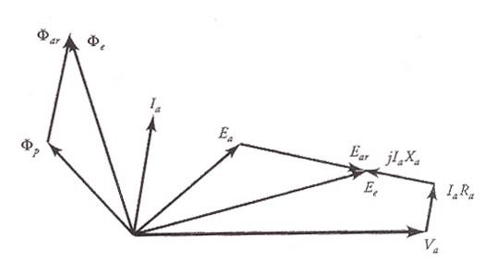

**Figure 5: The phasor diagram showing the effect of armature reaction when the power factor of the load is leading.**

Both the magnetization reactance and the leakage reactance are present at the same time. It is rather difficult to separate one reactance from the other. For this reason, the two reactances are combined together and the sum

*Xs*  *Xm*  *Xa*

is called the **synchronous reactance**. The synchronous reactance is usually very large compared with the resistance of the armature winding. We can now define

## 

the **synchronous impedance** on a per-phase basis as

*Zs*  *Ra* 

*j Xs*

#### *Synchronous Generator Tests*

To obtain the ***parameters of a synchronous generator***, we perform three simple tests as described below.

###### The Resistance Test

This test is conducted to measure-winding resistance of a synchronous generator when it is at rest and the field winding is open. The resistance is measured between two lines at a time and the average of the three resistance readings is taken to be the measured value of the resistance, *RL*, from line to line. If the generator is Y- connected, the per-phase resistance is

*Ra*  0.5 *RL*

###### The Open-Circuit Test

The open-circuit test, or the **no-load test**, is performed by

* + 1. Generator is rotated at the rated speed.
    2. No load is connected at the terminals.
    3. Field current is increased from 0 to maximum.
    4. 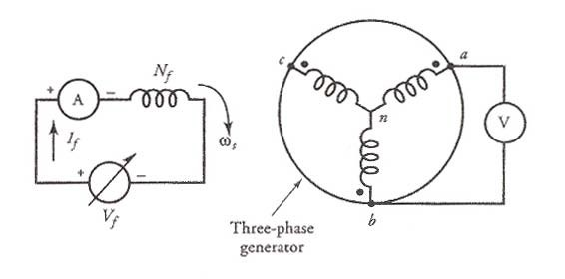Record values of the terminal voltage and field current value.

**Circuit diagram to perform open-circuit test.**

With the terminals open, IA=0, so EA = V It is thus possible to construct a plot of EA or VT vs IF graph. This plot is called open-circuit characteristic (OCC) of a generator. With this characteristic, it is possible to find the internal generated voltage of the generator for any given field current.

**Open-circuit characteristic (OCC) of a generator**

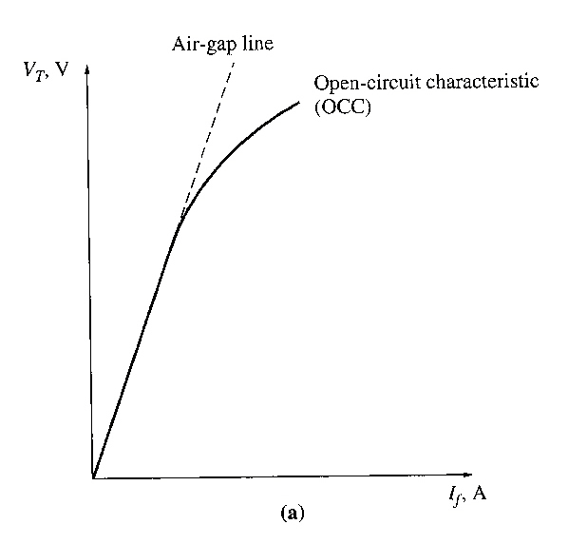

The OCC follows a straight-line relation as long as the magnetic circuit of the synchronous generator does not saturate. Since, in the linear region, most of the applied mmf is consumed by the air-gap, the straight line is appropriately called the ***air-gap line***.

###### The Short-Circuit Test

The short-circuit test provides information about the current capabilities of a synchronous generator. It is performed by

1. Generator is rotated at rated speed.
2. Adjust field current to 0.
3. Short circuit the terminals.
4. Measure armature current or line current as the field current is increased.

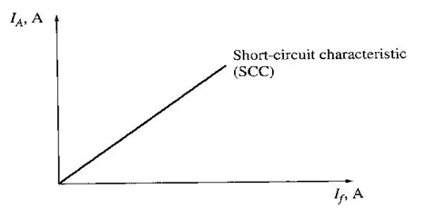

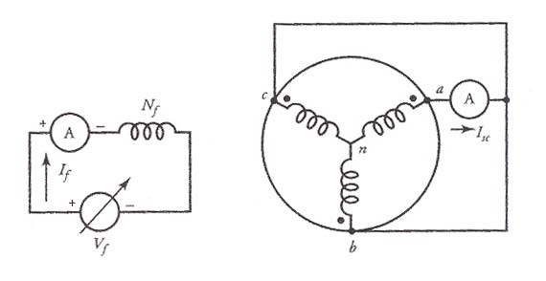SCC is essentially a straight line. To understand why this characteristic is a straight line, look at the equivalent circuit below when the terminals are short circuited.

**Circuit diagram to perform short-circuit test.**

When the terminals are short circuited, the armature current IA is:

*I*  *EA*

*A*

And its magnitude is:

*EA*

*I A*

*R*2

*A*

* *X* 2

*S*

*RA* 

*jX S*

 ***From both tests,*** here we can find the internal machine impedance (EA from OCC, IA from SCC):

*ZS* 

 *EA*

*I A*

*R*2

*A*

* *X* 2

*S*

Since Xs >> RA, the equation reduces to:

*EA*

*Xs* 

*I*

*A*

*V*

 *oc*

*IA*

###### Short Circuit Ratio

*Ratio of the field current required for the rated voltage at open circuit to the field current required for rated armature current at short circuit.*

𝐼𝐼𝑓𝑓 ,𝑂𝑂𝑆𝑆

𝑆𝑆𝑆𝑆𝑆𝑆 =

𝐼𝐼𝑓𝑓 ,𝑆𝑆𝑆𝑆

1

𝑆𝑆𝑆𝑆, 𝑆𝑆𝑆𝑆𝑆𝑆 =

𝑋𝑋

𝑠𝑠

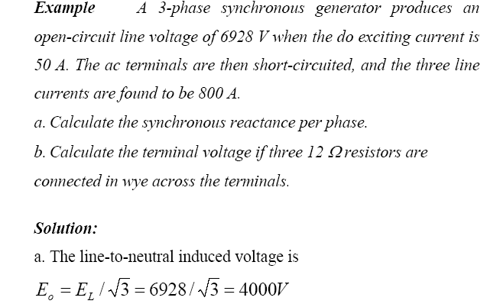

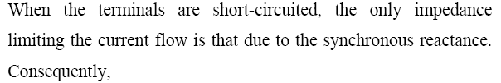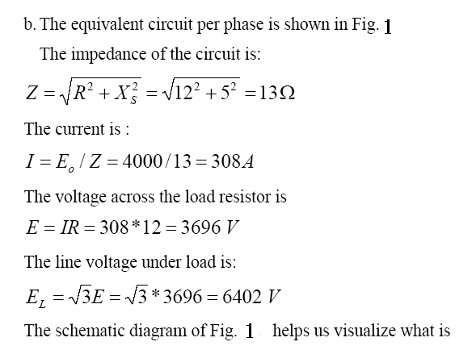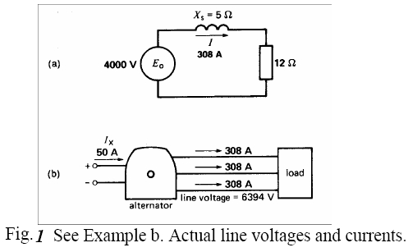

**Example: The following data are taken from the open- and short-circuit characteristics of a 45-kVA, three-phase, Y-connected, 220-V (line-to-line), six-pole, 60-Hz synchronous machine. From the open-circuit characteristic:**

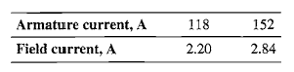**Line-to-line voltage = 220 V Field current = 2.84 A From the short-circuit characteristic:**

**From the air-gap line:**

**Field current = 2.20 A Line-to-line voltage = 202 V**

**Compute the unsaturated value of the synchronous reactance, its saturated value at rated voltage, and the short-circuit ratio. Express the synchronous reactance in ohms per phase and in per unit on the machine rating as a base.**

###### Solution

At a field current of 2.20 A the line-to-neutral voltage on the air-gap line is



and for the same field current the armature current on short circuit is





Note that rated armature current is

Therefore, la, sc = 1.00 per unit. The corresponding air-gap-line voltage is



in per unit

The saturated synchronous reactance can be found from the open- and short-circuit characteristics



In per unit



Finally, from the open- and short-circuit characteristics, the short-circuit ratio is given by



The inverse of the short-circuit ratio is equal to the per-unit saturated synchronous reactance



**H.W**

Calculate the saturated synchronous reactance (in Ω/phase and per unit) of a 85 kVA synchronous machine which achieves its rated open-circuit voltage of 460 V at a field current 8.7 A and which achieves rated short-circuit current at a field current of 11.2 A. **[Answer: Xs = 3.21 Ω/phase = 1.29 per unit]**

### Voltage regulation of Alternator

The voltage regulation of an Alternator is defined as the change in terminal voltage from no-load to load condition expressed as per-unit or percentage of terminal voltage at load condition; the speed and excitation conditions remaining same.

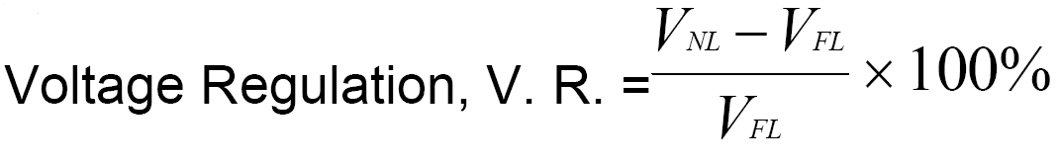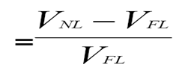

**Per unit**

#### *Determination of Voltage Regulation*

The following are the three methods which are used to determine the voltage regulation of smooth cylindrical type Alternators

###### Synchronous impedance / EMF method

1. **Ampere-turn / MMF method**
2. **Potier / ZPF method**
3. *Synchronous impedance / EMF method*

Synchronous impedance is calculated from OCC and SCC as Zs = E0/Isc(for same If)

A compromised value of Zs is normally estimated by taking the ratio of (E0/Isc) at normal field current If. A normal field current If is one which gives rated voltage

Vr on open circuit.

Zs = Vr/Isc

*Advantages:*

* Simple no load tests (for obtaining OCC and SCC) are to be conducted
* Calculation procedure is much simpler

*Disadvantages:*

* The value of voltage regulation obtained by this method is always higher than the actual value.

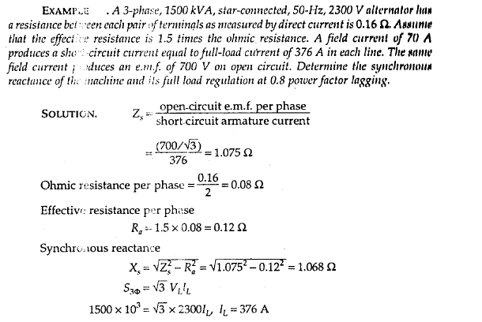

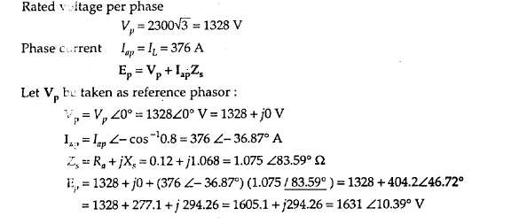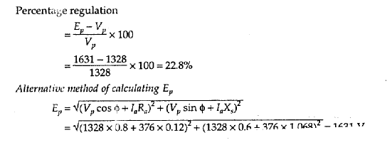

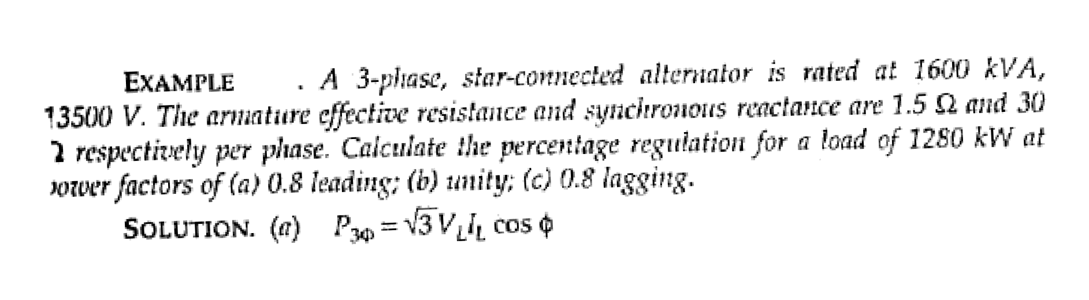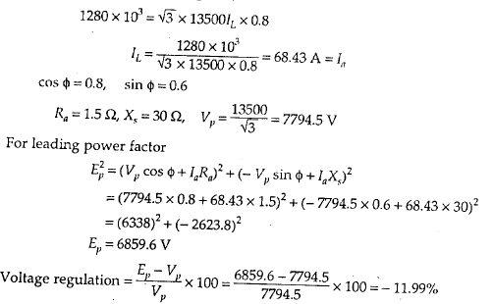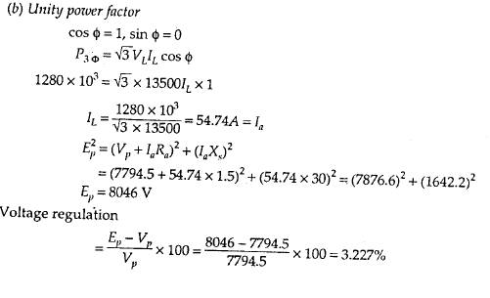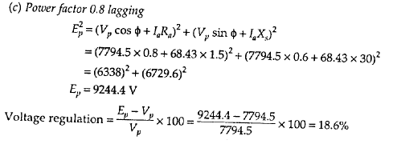

1. *Ampere-turn / MMF method*

The ampere-turn /MMF method is the converse of the EMF method in the sense that instead of having the phasor addition of various voltage drops/EMFs, here the phasor addition of MMF required for the voltage drops are carried out. Further the effect of saturation is also taken care of.

Data required for MMF method are:

* Effective resistance per phase of the 3-phase winding R
* Open circuit characteristic (OCC) at rated speed/frequency
* Short circuit characteristic (SCC) at rated speed/frequency



Compared to the ***EMF*** method, ***MMF*** method, involves more number of complex calculation steps. Further the OCC is referred twice and SCC is referred once while predetermining the voltage regulation for each load condition. Reference of OCC takes care of saturation effect. As this method requires more effort, the final result is very close to the actual value. Hence this method is called optimistic method.

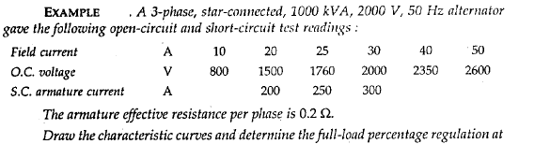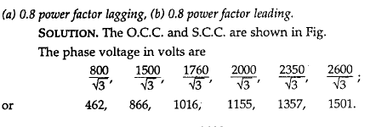

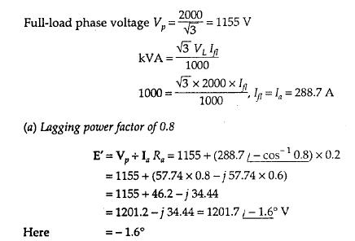

**δ**

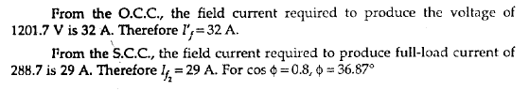

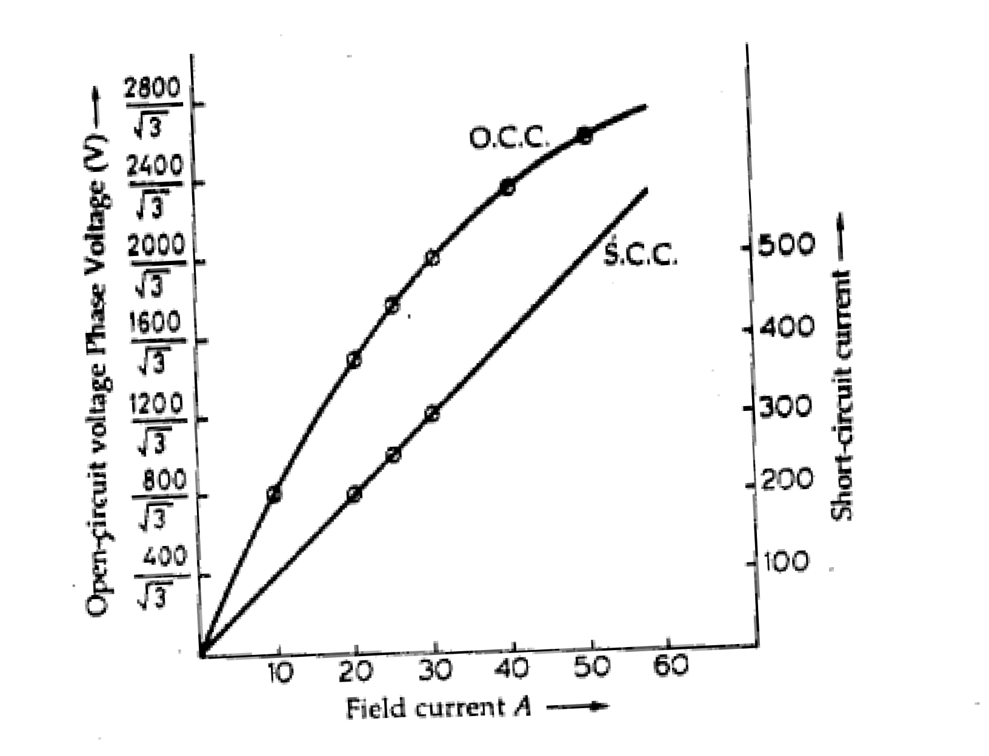

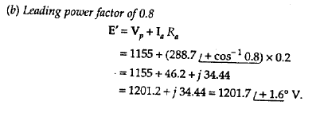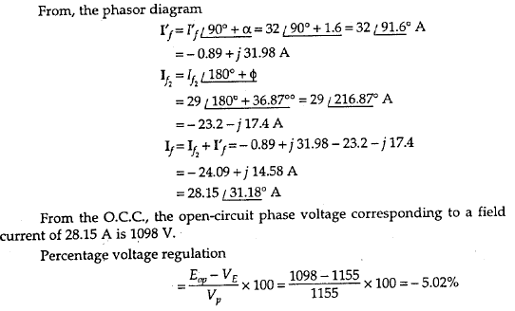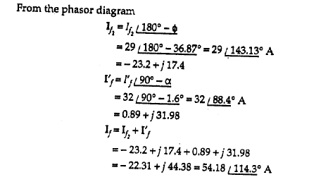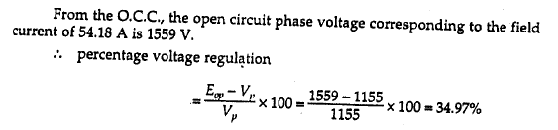

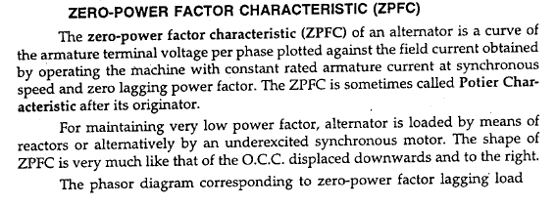

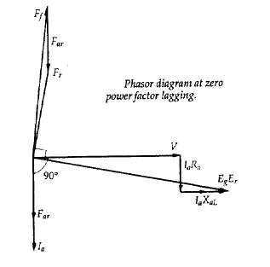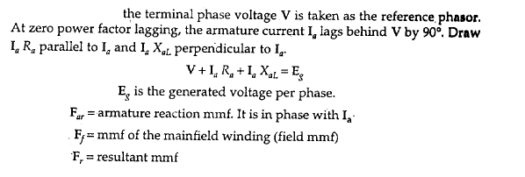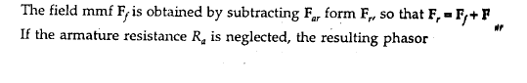

**diagram**

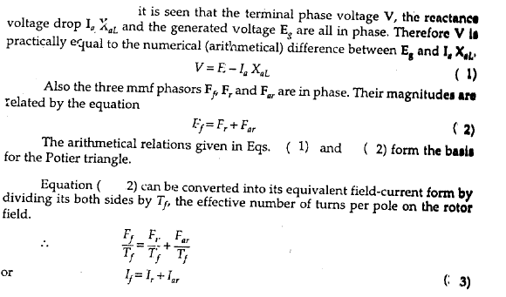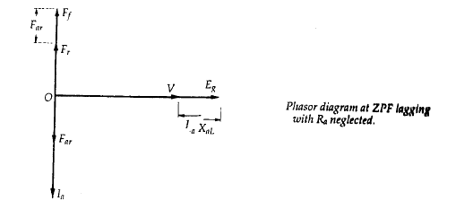

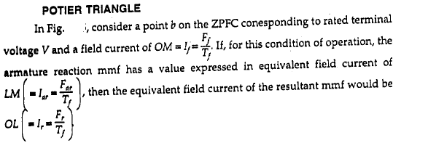

**1**

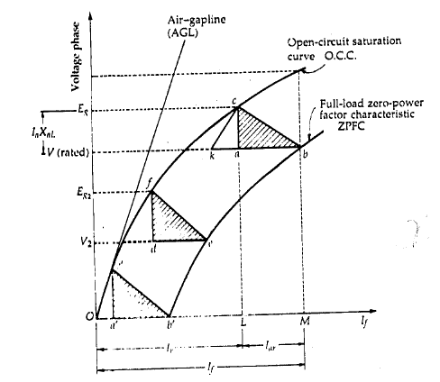

###### Fig. 1Potier triangle

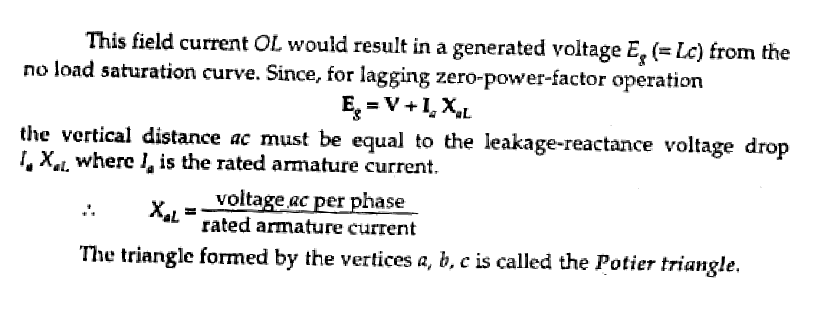

1

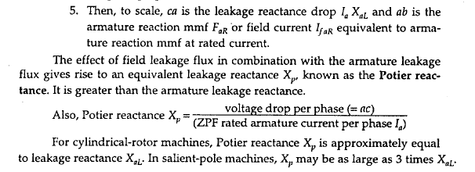



**Fig.2**

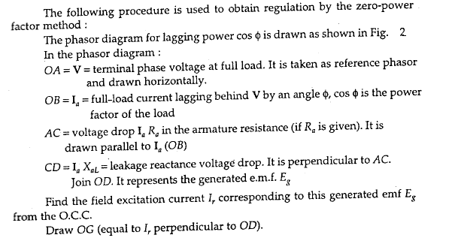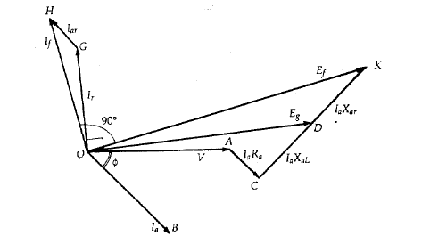

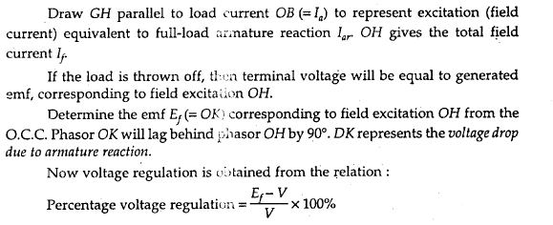

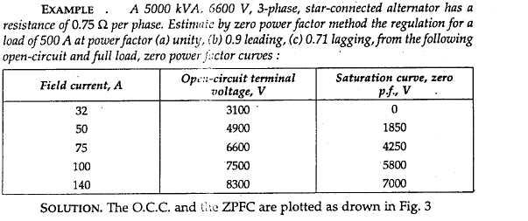

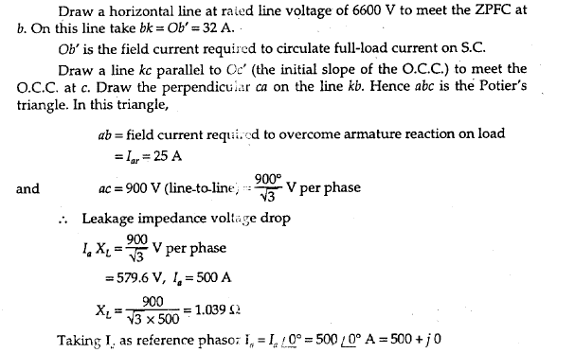

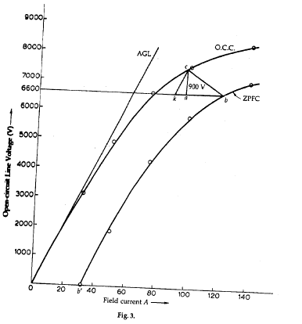

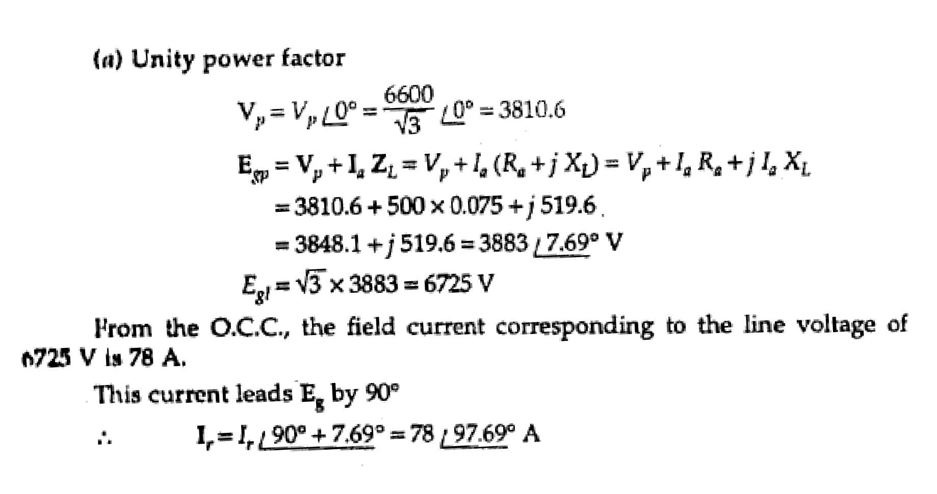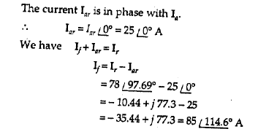

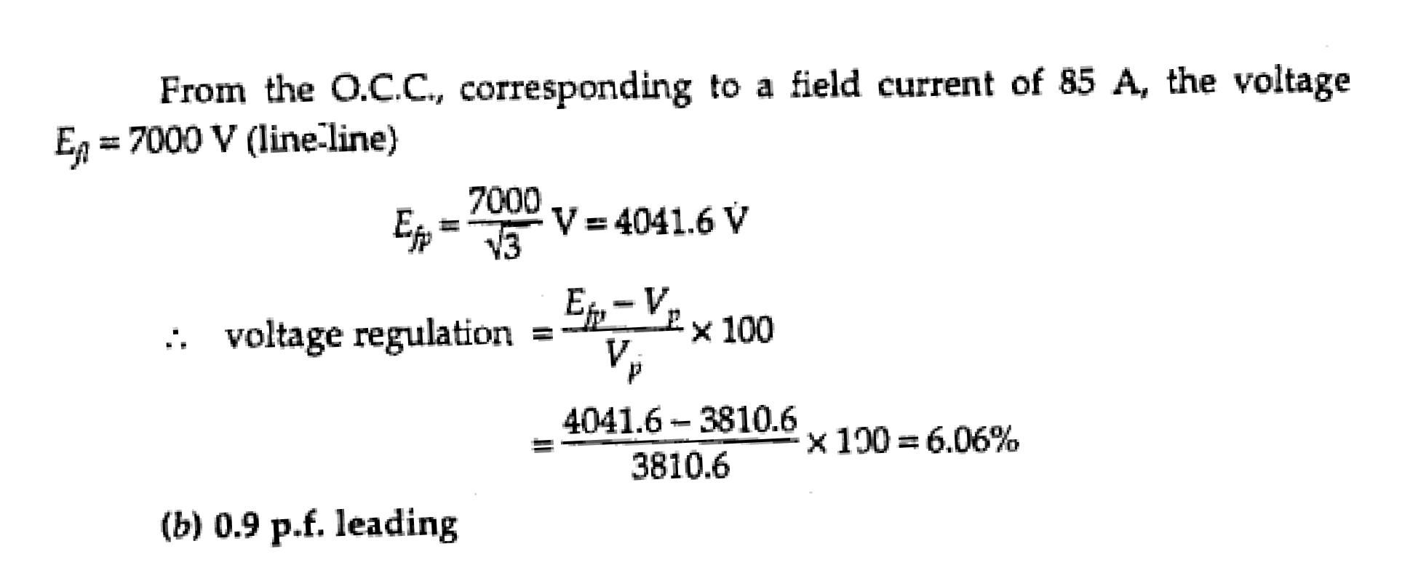

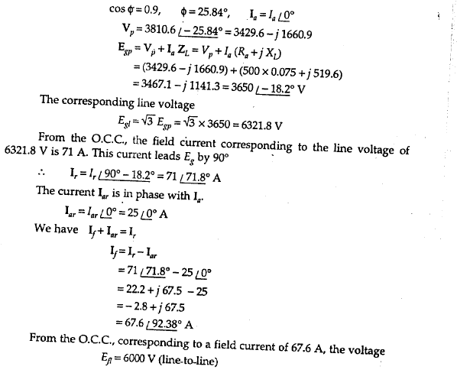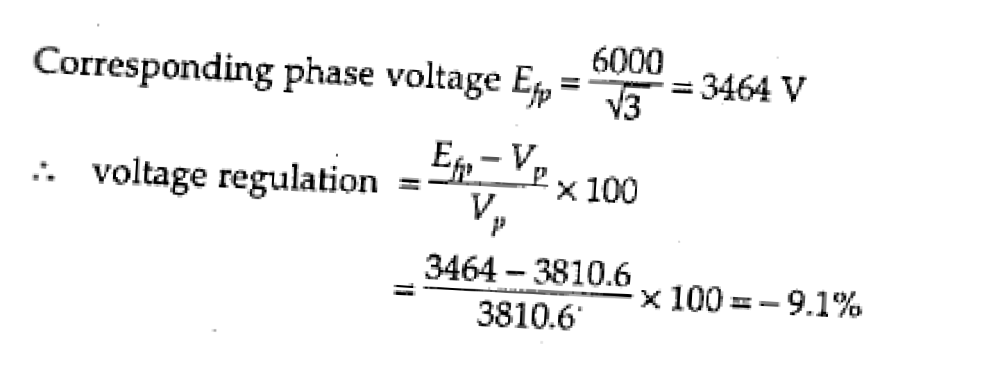

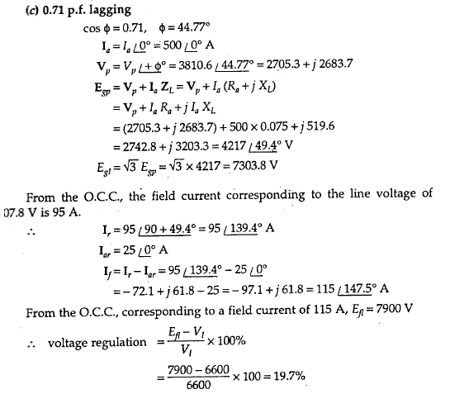

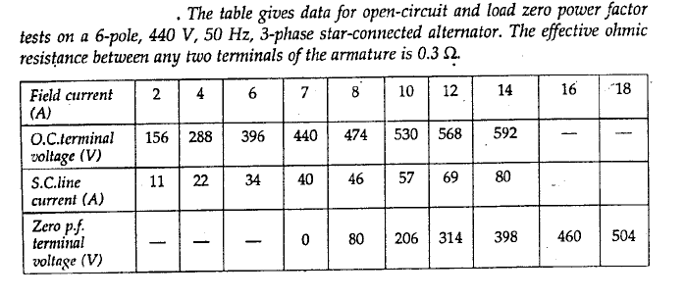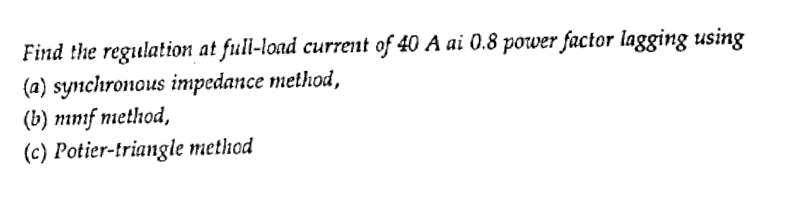

**H.W**

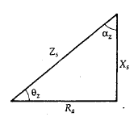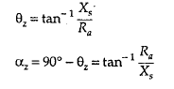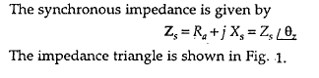

**Power flow transfer equations for a synchronous generator**

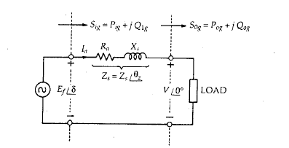

**Fig.1**

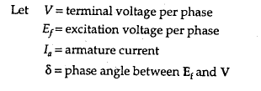

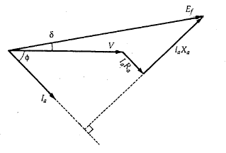

Let the subscripts *i, o, g* denote input, output, generator.

By *KVL* in the network of Fig.1.

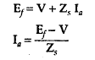



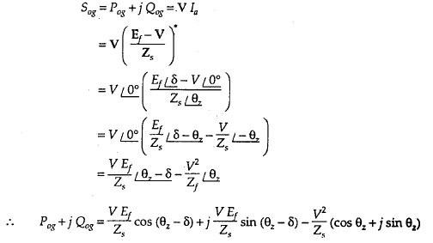



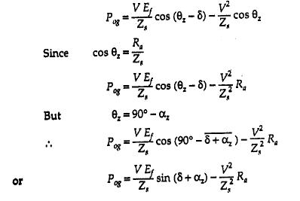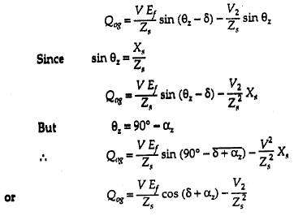

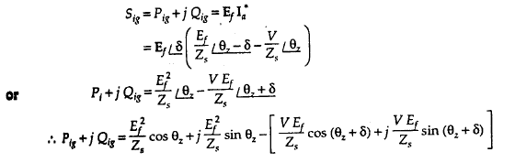

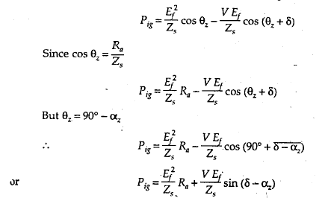



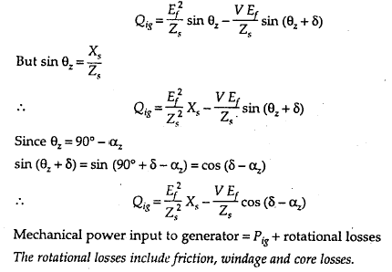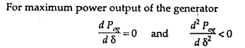



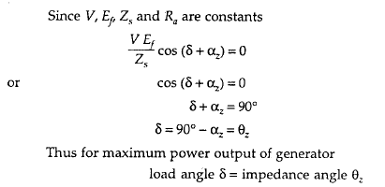

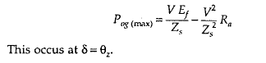

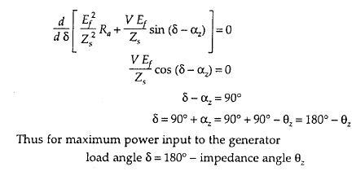

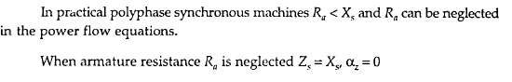

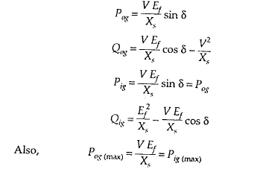

###### Salient-Pole Synchronous Generator — Two-Reaction Theory

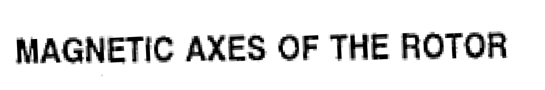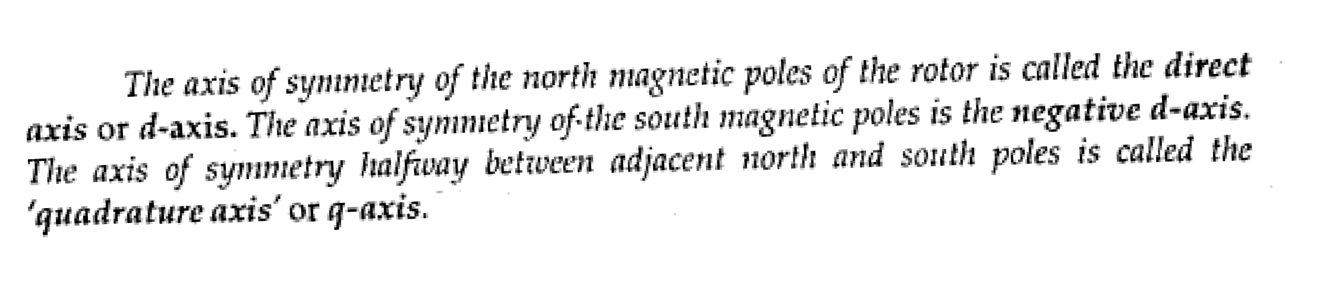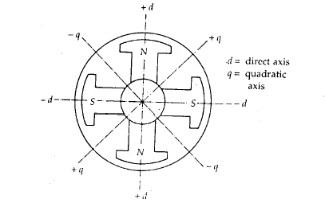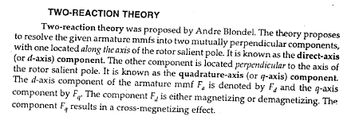

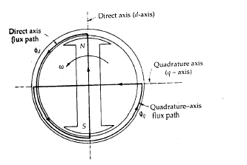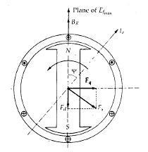***Salient-pole generators***, such as hydroelectric generators, have armature inductances that are a function of rotor position, making analysis one step more complicated. The key to analysis of such machines is to separate mmf and flux into two orthogonal components. The two components are aligned with the direct axis and the quadrature axis of the machine. The direct axis is aligned with the field winding, while the quadrature axis leads the direct by 90°.

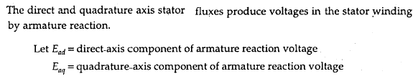

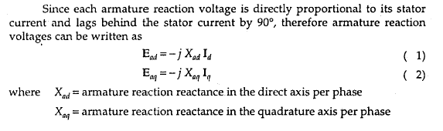

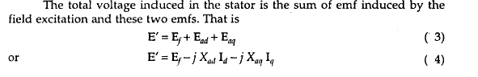

Synchronous Generators Dr. Suad Ibrahim Shahl

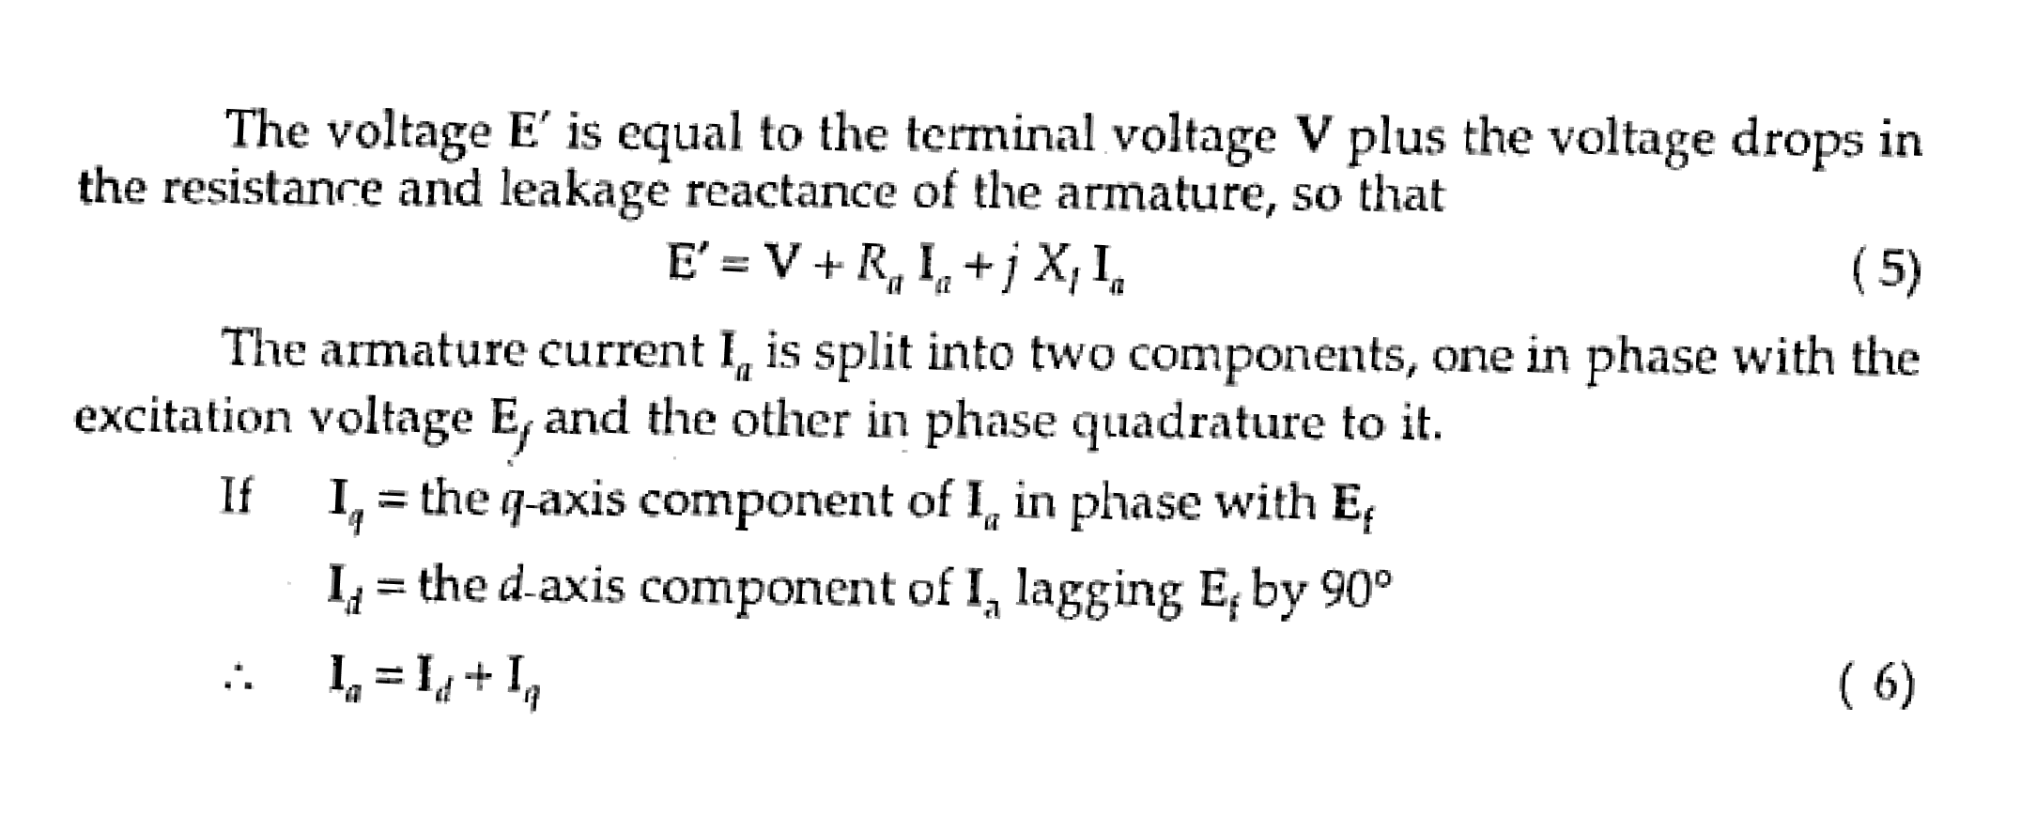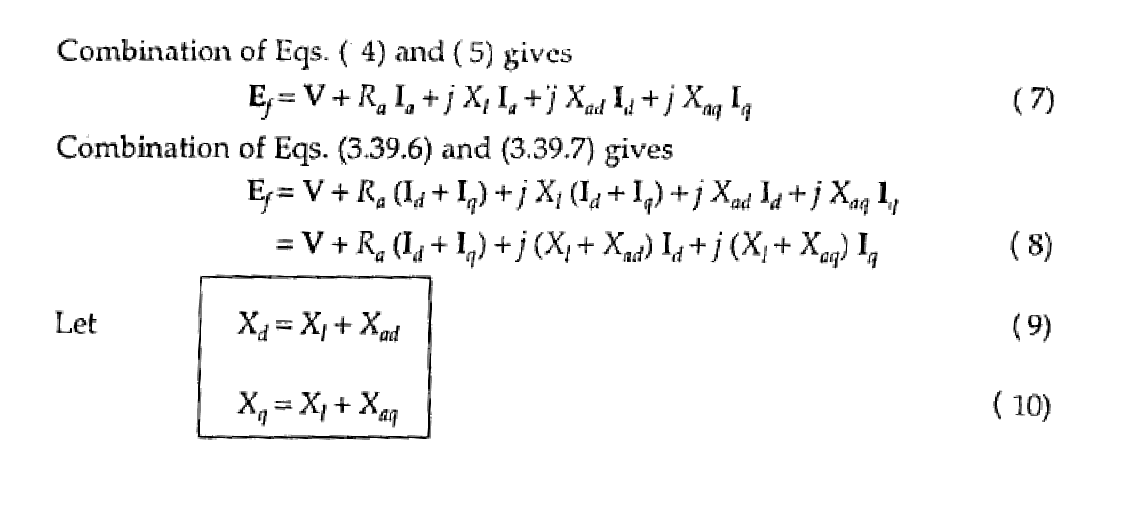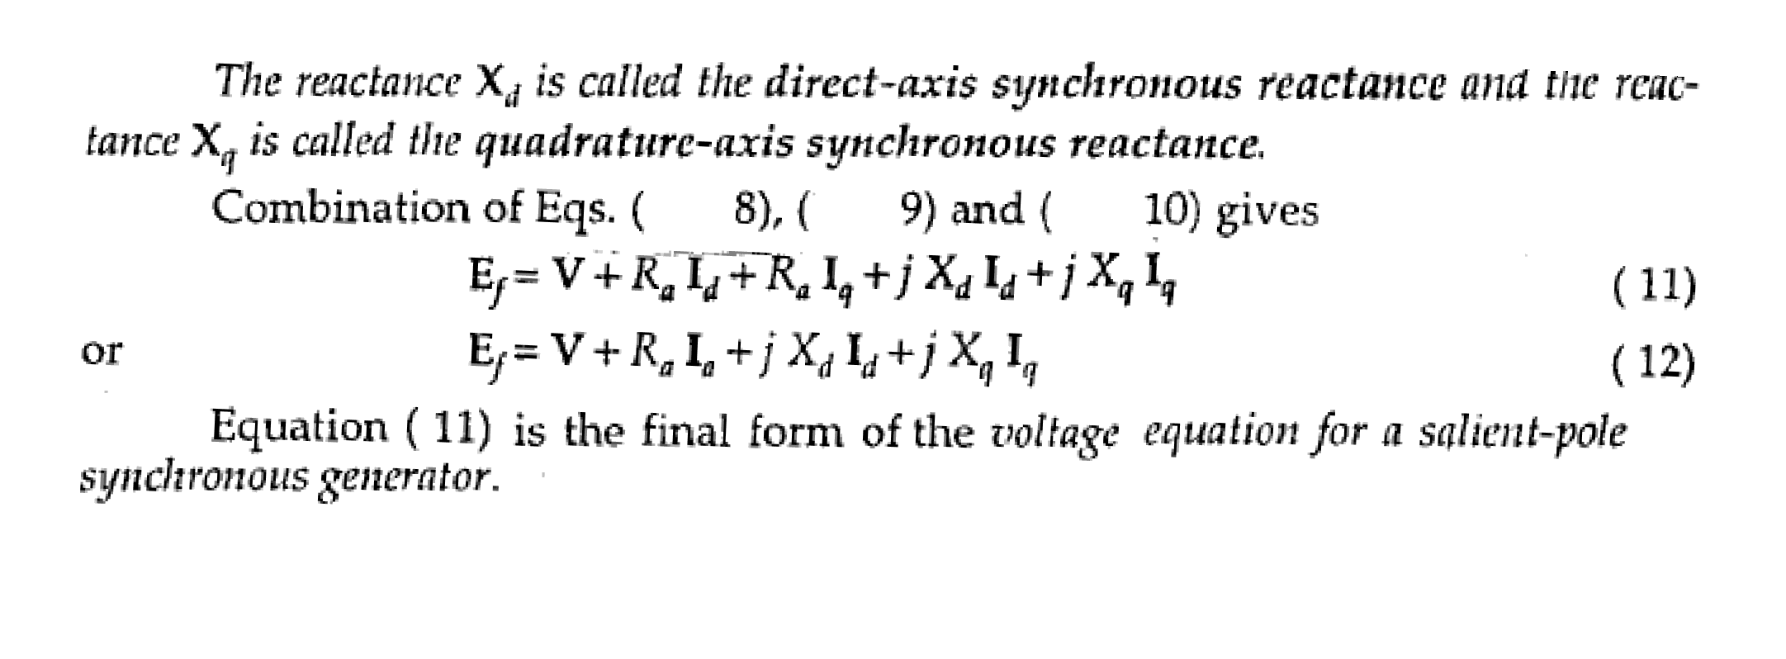

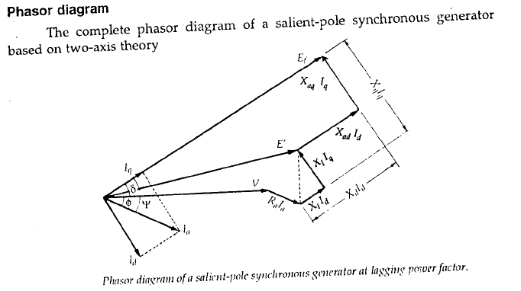

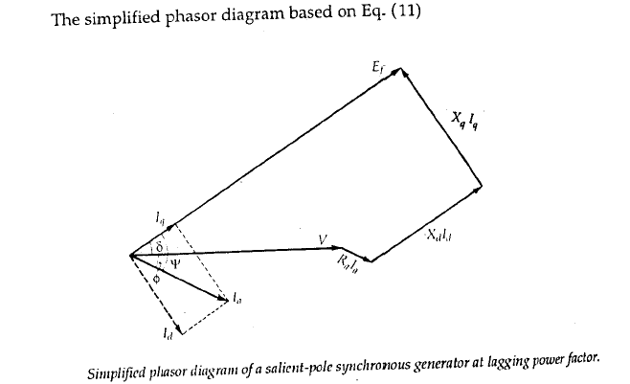

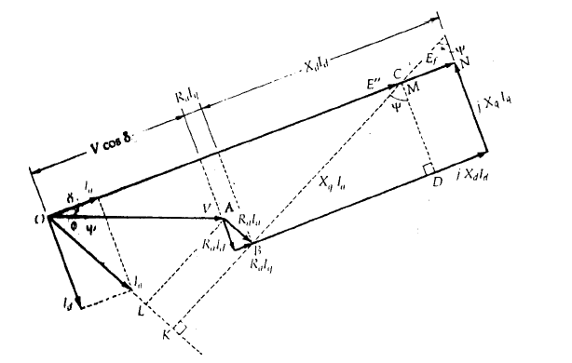

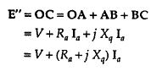

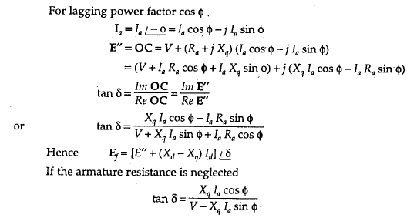

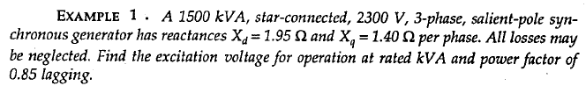

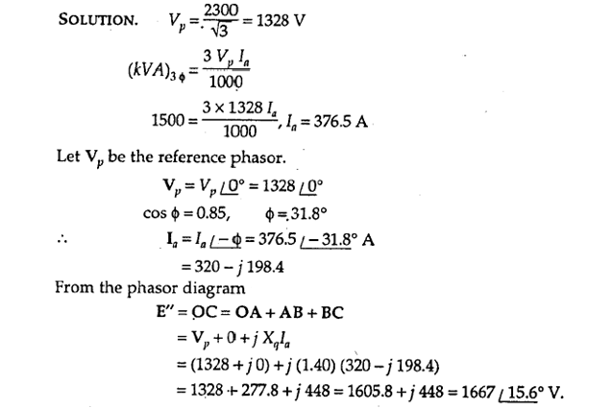

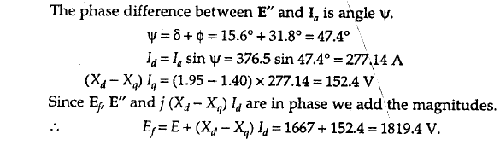

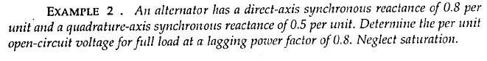

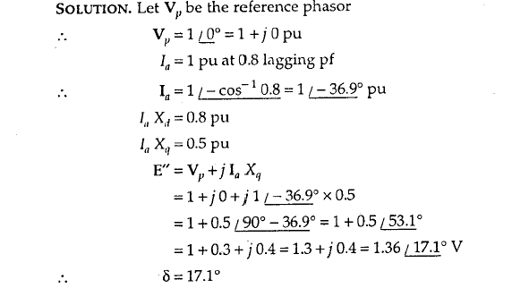

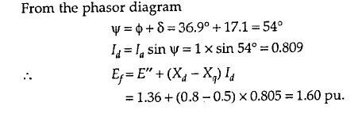

# Power-angle Characteristics of Synchronous Generators

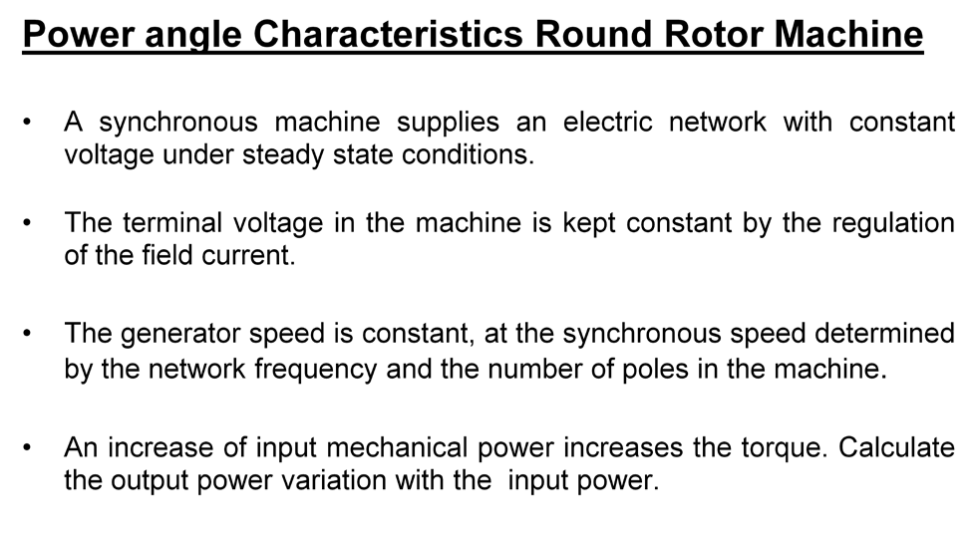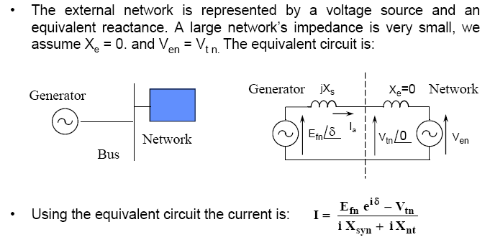

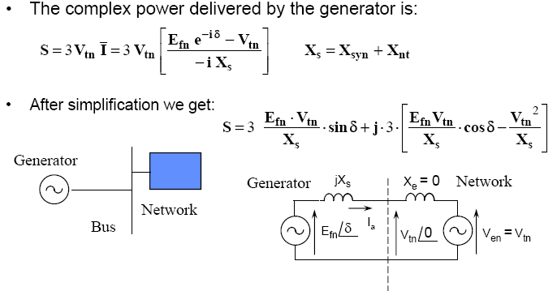

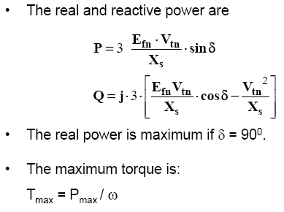

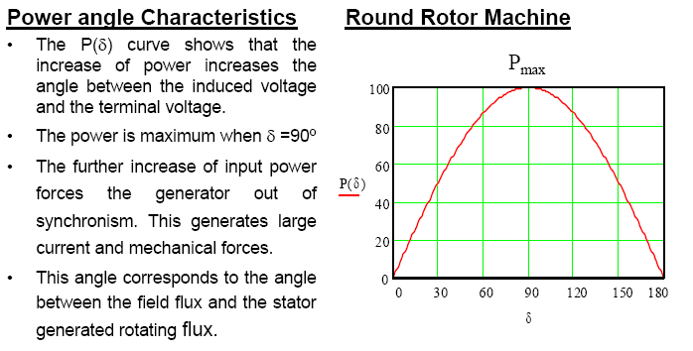

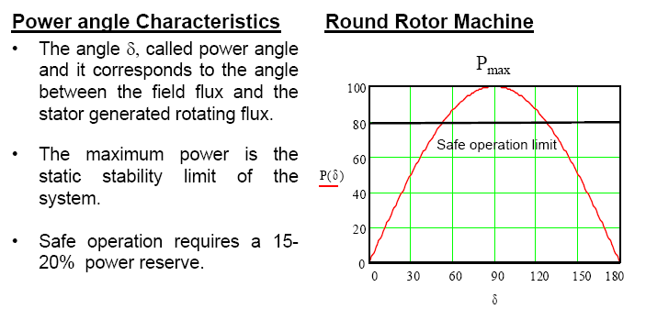

**Salient-Pole Synchronous Generator**

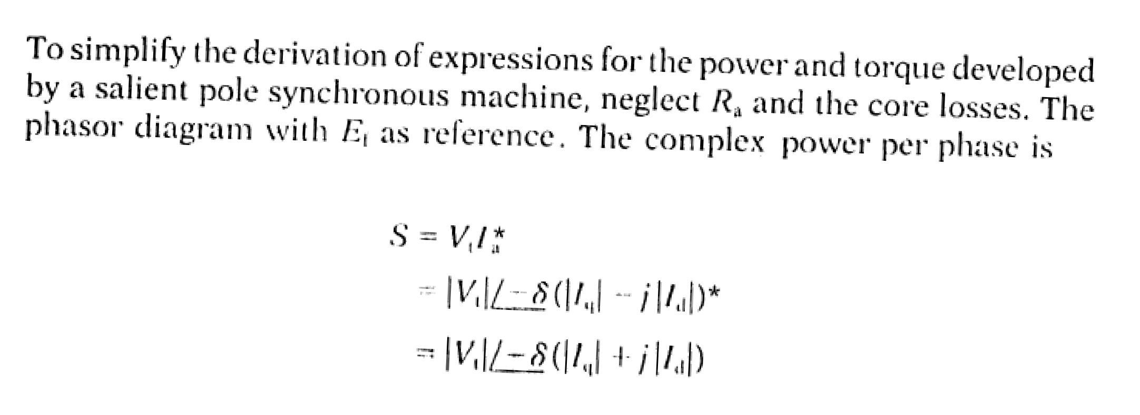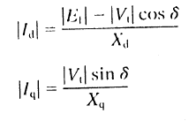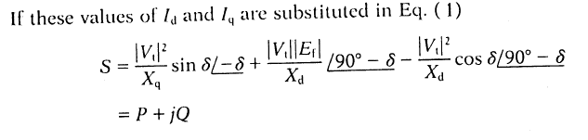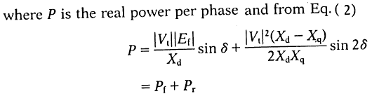

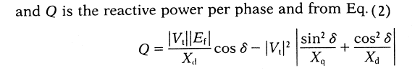

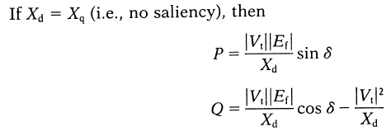

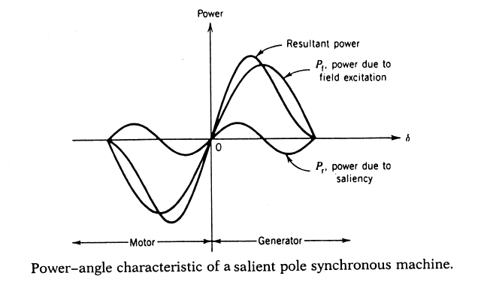

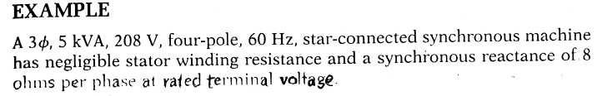

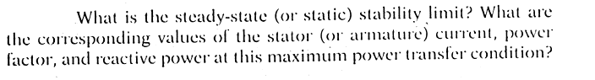

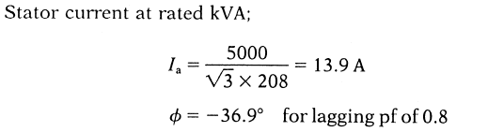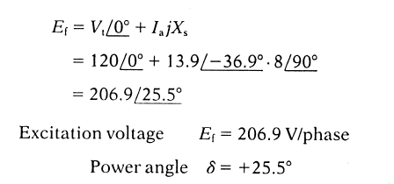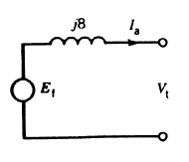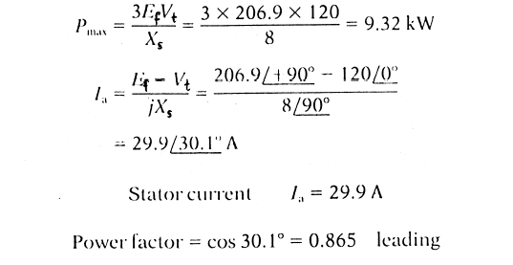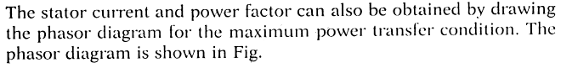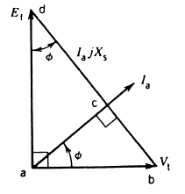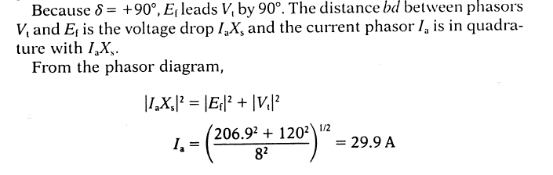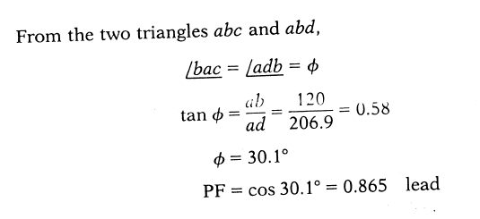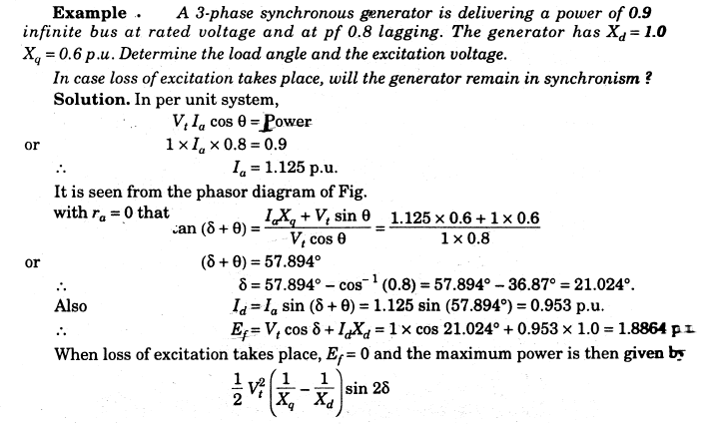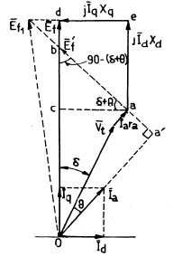

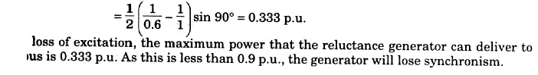

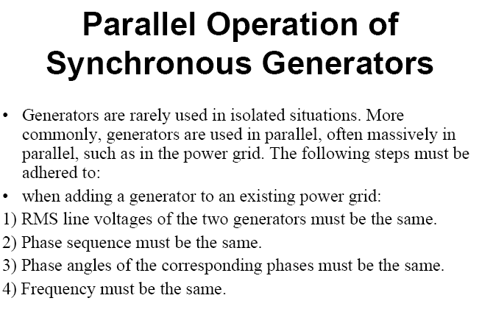

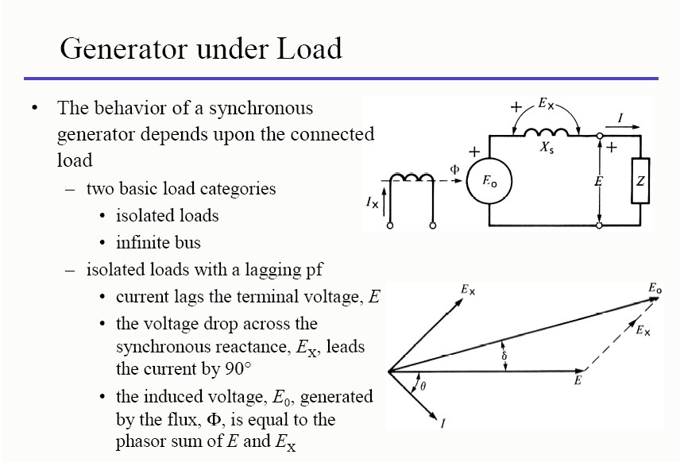

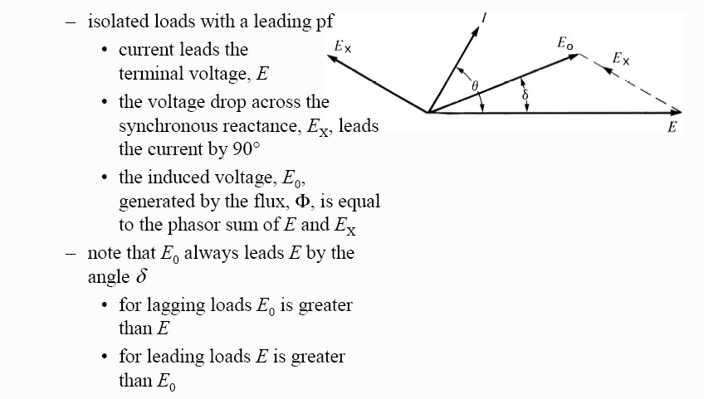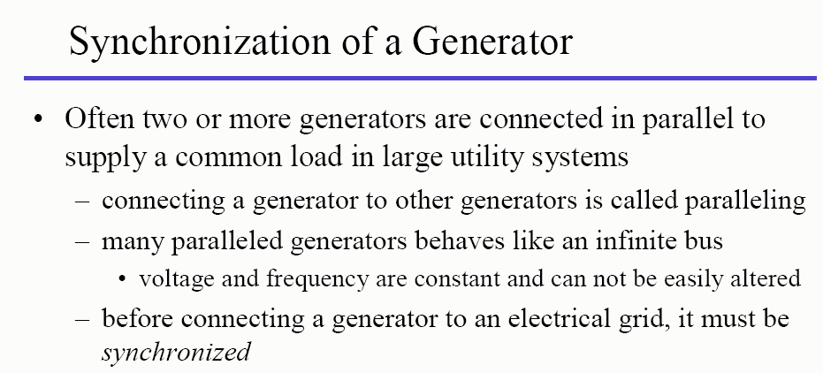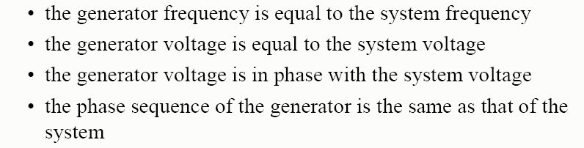

Synchronizing may be achieved with the help of ***synchronizing lamps***, the ***rotary lamp method*** being the most popular. Alternatively, a device known as the ***synchroscope*** may conveniently be used to facilitate synchronizing.

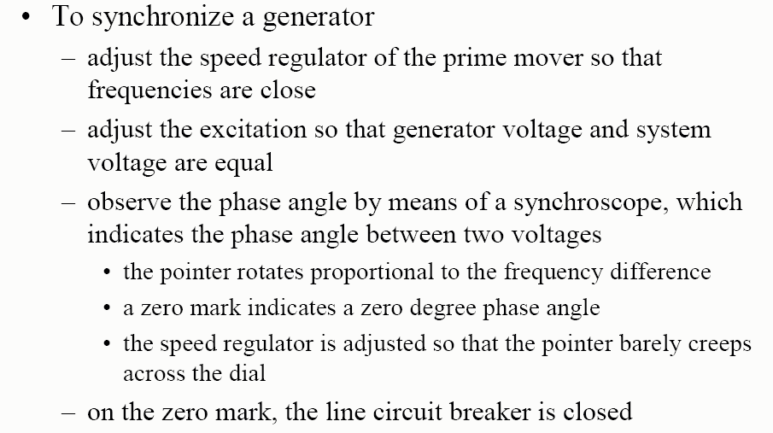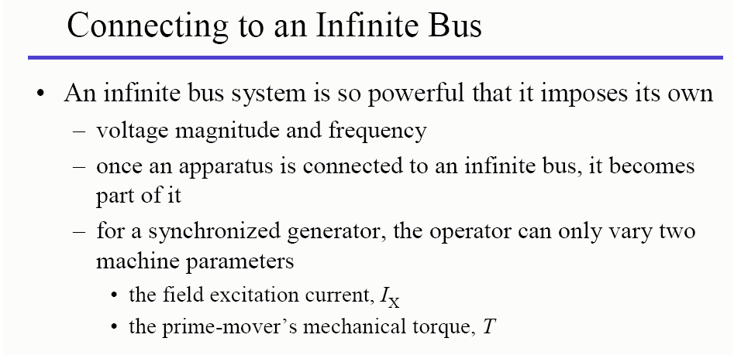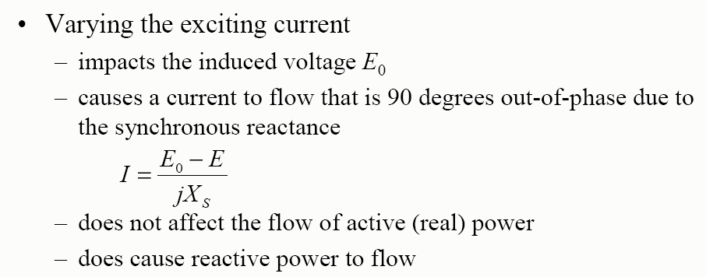

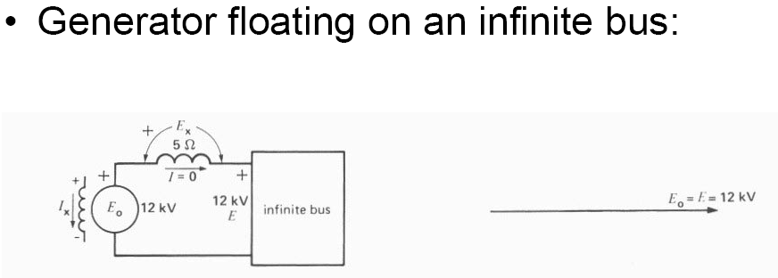

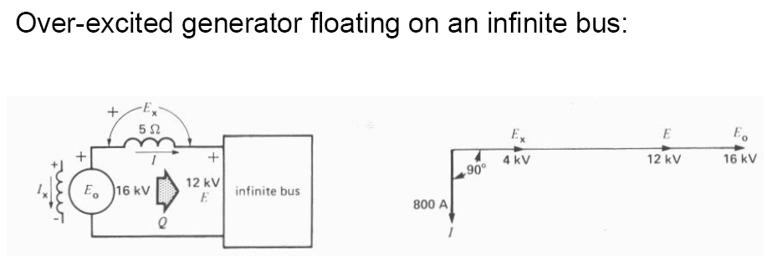

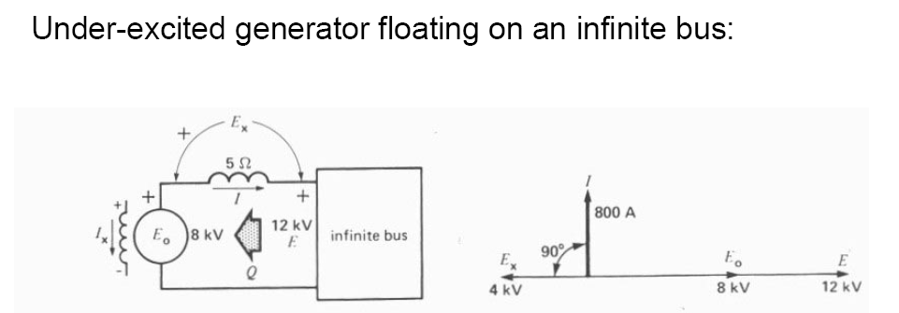

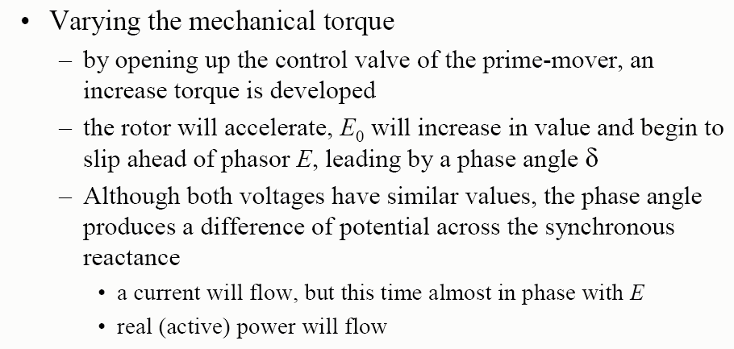

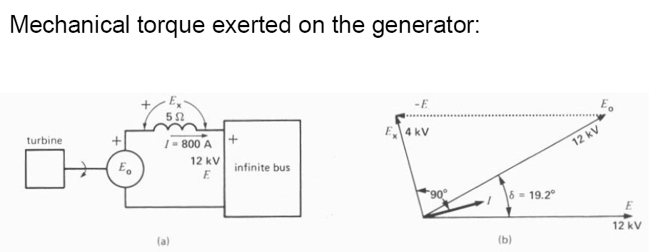





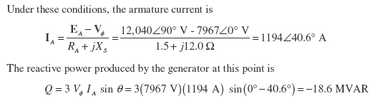

###### Example:

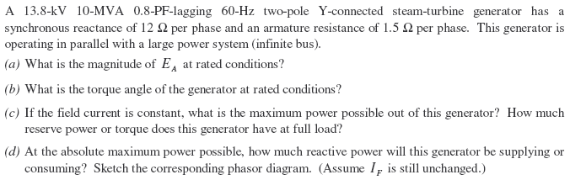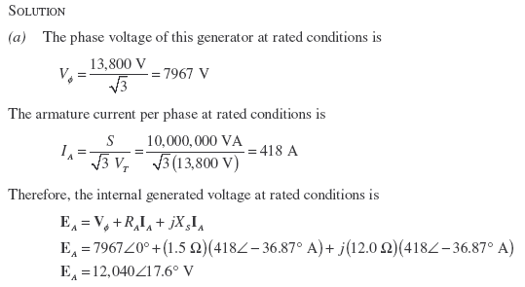

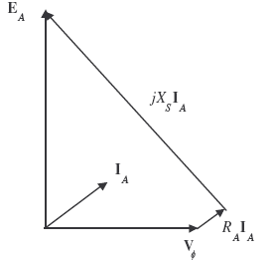

**Example: Two alternators running in parallel supply lighting load of 2500 KW and a motor load of 5000 KW at 0.707 P.F. one machine is loaded to 4000 KW at a P.F. of 0.8 lagging. What is the KW output and P.F. of the other machine?**

**Solution: *For first machine.***

Load power (or KW) of lighting load, p = 2500 KW

Load reactive power (or KVAR) of lighting load, 𝑄𝑄 = 𝑃𝑃

cos ∅

sin ∅

∵ cos ∅ = 1 𝑓𝑓𝑆𝑆𝑓𝑓 𝑙𝑙𝑙𝑙𝑙𝑙ℎ𝑡𝑡𝑙𝑙𝑡𝑡𝑙𝑙 𝑙𝑙𝑆𝑆𝑙𝑙𝑙𝑙

∴ ∅ = 0 𝑙𝑙𝑡𝑡𝑙𝑙 sin ∅ = sin 0 = 0 2500

***For second machine***

*P of motor load=5000 KW*

∴ 𝑄𝑄 𝑆𝑆𝑓𝑓 𝑙𝑙𝑙𝑙𝑙𝑙ℎ𝑡𝑡𝑙𝑙𝑡𝑡𝑙𝑙 𝑙𝑙𝑆𝑆𝑙𝑙𝑙𝑙 =

× 0 = 0

1

𝑃𝑃. 𝐹𝐹. cos ∅ = 0.707 ∴ sin ∅ = 0.707

∴ 𝑄𝑄 𝑆𝑆𝑓𝑓 𝑚𝑚𝑆𝑆𝑡𝑡𝑆𝑆𝑓𝑓 𝑙𝑙𝑆𝑆𝑙𝑙𝑙𝑙 =

𝑃𝑃

cos ∅

× sin ∅ =

5000

0.707

× 0.707 = 5000 𝐾𝐾𝐾𝐾𝐾𝐾𝑆𝑆

𝑇𝑇𝑆𝑆𝑡𝑡𝑙𝑙𝑙𝑙 𝑙𝑙𝑆𝑆𝑙𝑙𝑙𝑙 = 2500 + 5000 = 7500 𝐾𝐾𝐾𝐾

𝑇𝑇𝑆𝑆𝑡𝑡𝑙𝑙𝑙𝑙 𝐾𝐾𝐾𝐾𝐾𝐾𝑆𝑆 = 0 + 5000 = 5000 𝐾𝐾𝐾𝐾𝐾𝐾𝑆𝑆

**Load sharing**

Load taking by 1st machine= 4000 KW

∴ 𝑄𝑄 𝑆𝑆𝑓𝑓 1𝑠𝑠𝑡𝑡 𝑚𝑚𝑙𝑙𝑚𝑚ℎ𝑙𝑙𝑡𝑡𝑖𝑖 = 4000 × 0.6 = 3000 𝐾𝐾𝐾𝐾𝐾𝐾𝑆𝑆

0.8

∴ 2nd machine will supply

= 7500 − 4000 = 3500 𝐾𝐾𝐾𝐾

𝑙𝑙𝑡𝑡𝑙𝑙 𝑄𝑄 = 5000 − 3000 = 2000 𝐾𝐾𝐾𝐾𝐾𝐾𝑆𝑆

𝑆𝑆𝑙𝑙𝑡𝑡𝑚𝑚𝑖𝑖 𝑄𝑄 = 𝑃𝑃×sin ∅ = 𝑃𝑃 × tan ∅

cos ∅

𝑆𝑆𝑓𝑓 tan ∅ = 𝑄𝑄 = 2000 = 0.57142

𝑃𝑃 3500

𝑆𝑆𝑓𝑓 ∅ = tan−1 0.57142 = 29.7448𝑆𝑆

∴ 𝑝𝑝. 𝐹𝐹. , cos ∅ = cos 29.7448𝑆𝑆 = 0.8682 𝑙𝑙𝑙𝑙𝑙𝑙𝑙𝑙𝑙𝑙𝑡𝑡𝑙𝑙